**Jenkins Assignment**

1. **How to change default port of Jenkins (8080) to some other port.**

Default port for Jenkins [8080]

New Port for Jenkins [8081]

* To change the default port of Jenkins, we need to have a Jenkins Server EC2 instance.

Add the below commands in user data section of EC2 instance before launching it to install Jenkins on it

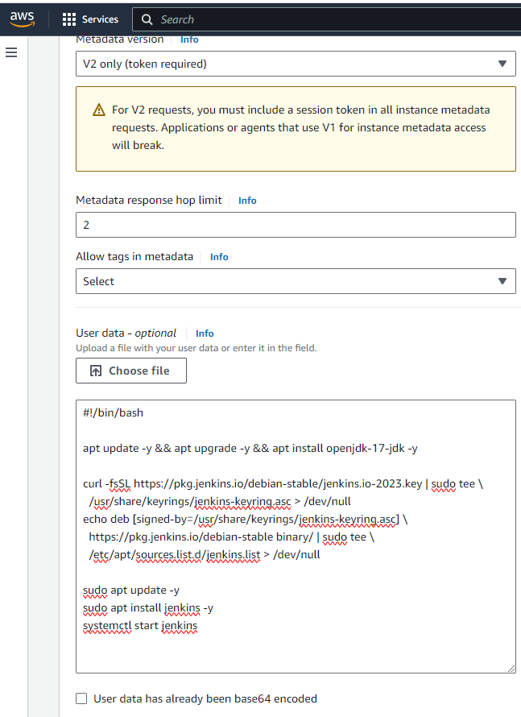

* Once the EC2 instance is up, Post deployment steps are performed for configuring Jenkins to setup the Jenkins server. Once Jenkins is configured, we see the below dashboard screen.

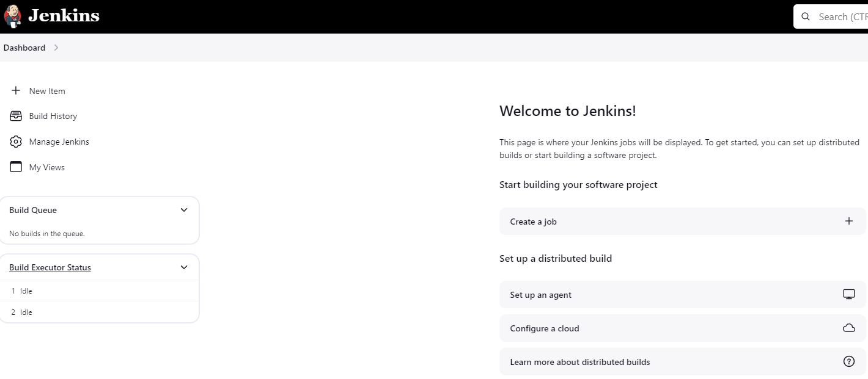

* Now we will go to the terminal and do the below changes:

vi /etc/default/jenkins (Edit the jenkins configuration file)



* Scroll down until you find the following lines:

# port for HTTP connector (default 8080; disable with -1)

HTTP_PORT=8080

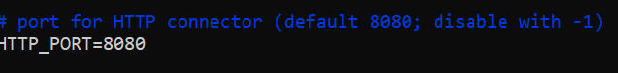

* Edit the second line to include the port number you want to specify)

# port for HTTP connector (default 8080; disable with -1)

HTTP_PORT=8081



* Esc, then: wq! (Save and exit the file)
* Now we will edit the jenkins service file with new port number

vi usr/lib/systemd/system/jenkins.service (Open Jenkins Service)



* Scroll down until you find the below line:

Environment="JENKINS_PORT=8080"

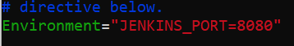

* Change the port with the new port number

Environment="JENKINS_PORT=8081"

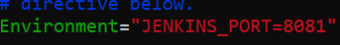

Esc, then: wq! (Save and exit the file)

* Reload the Daemon

systemctl daemon-reload

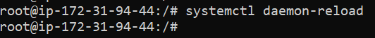

* Restart Jenkins Service

systemctl restart jenkins



* Verify on the Webpage with Public IP: New port Number

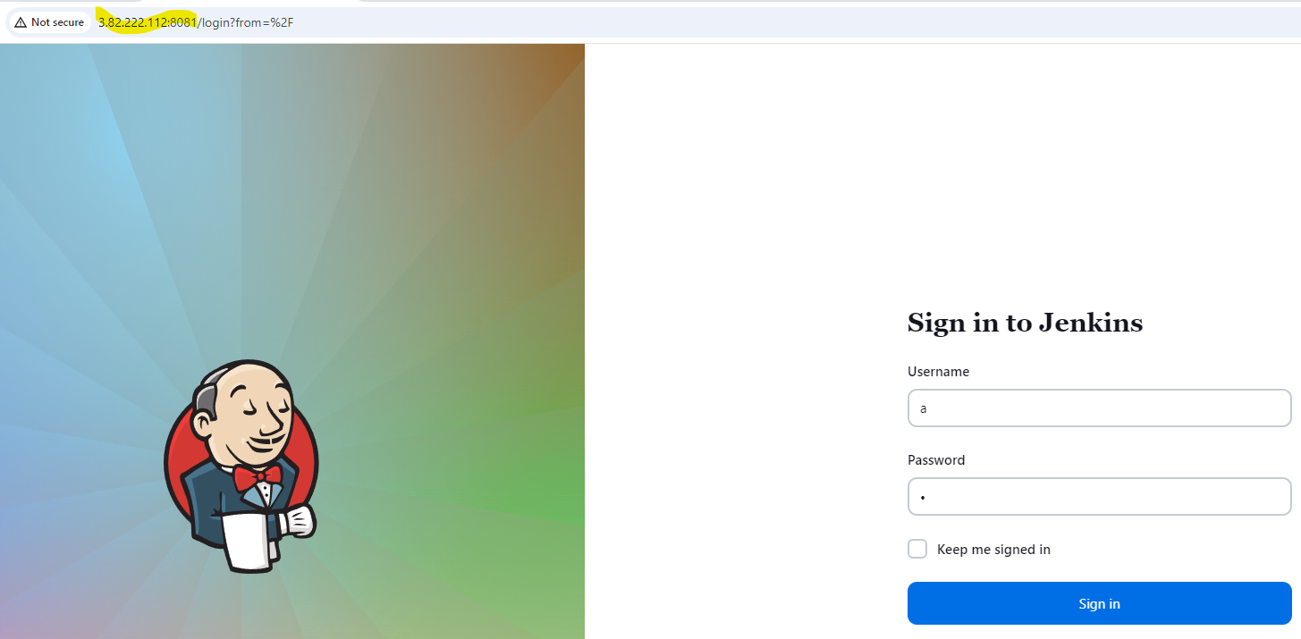

* Now to make sure all the functionalities of Jenkins are working properly. Need make change to Jenkins URL to reflect the new port Number

Manage Jenkins > System > Jenkins Location > Jenkins URL

Before making the change.

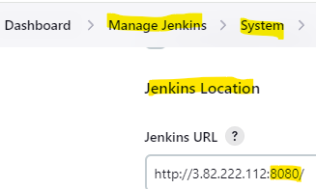

change from URL with old port Number to URL with new port number and hit save

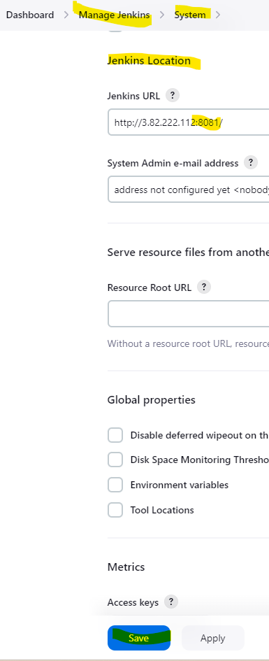

* Restart Jenkins Service

systemctl restart jenkins



* The port change is completed successfully.

1. **How to change Home Directory of Jenkins.**

Default home directory path [/var/lib/jenkins]

New Path we want to give is [/home/jenkins_home/jenkins]

* To change the default home directory of Jenkins, we need to have a Jenkins Server EC2 instance.

Add the below commands in user data section of EC2 instance before launching it to install Jenkins on it



* Once the EC2 instance is up, Post deployment steps are performed for configuring Jenkins to setup the Jenkins server. Once Jenkins is configured, we see the below dashboard screen.



* Now we will go to the terminal and do the below changes:
* Stop Jenkins Service

systemctl stop jenkins

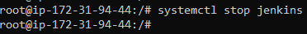

* Create a new Jenkins Home directory using the mkdir command

mkdir /home/jenkins_home



* Change permissions for the new home directory

chown jenkins:jenkins /home/jenkins_home



* Copy the contents from the old Jenkins Home directory to the new one

cp -prv /var/lib/jenkins /home/jenkins_home

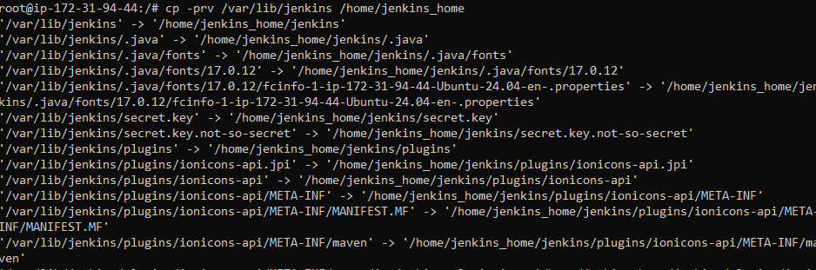

* Assign Jenkins as the user for the new home directory

usermod -d /home/jenkins_home jenkins



* Edit the Jenkins configuration file.

vi /etc/default/jenkins



* Scroll down until you reach the JENKINS_HOME entry

Edit the line to include the path to the new home directory

In our Case

NAME=jenkins

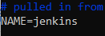

* Old home directory path

JENKINS_HOME=/var/lib/$NAME

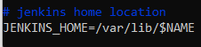

* New home directory path

JENKINS_HOME=/home/jenkins_home/$NAME

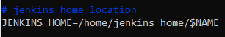

Esc, then: wq! (Save and exit the file)

* Now we will edit the jenkins service file with new port number

vi usr/lib/systemd/system/jenkins.service



* Scroll down until you reach the Environment and Working Directory

Edit the line to include the path to the new home directory

In our Case

* OLD Entry of Jenkins home path

Environment="JENKINS_HOME=/var/lib/jenkins"

WorkingDirectory=/var/lib/jenkins

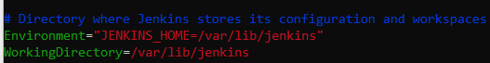

* NEW Entry of Jenkins home path

Environment="JENKINS_HOME=/home/jenkins_home/jenkins”

WorkingDirectory=/home/jenkins_home/jenkins

Esc, then: wq! (Save and exit the file)

* Reload the Daemon

systemctl daemon-reload



* Rename the old Jenkins home directory

mv /var/lib/jenkins /var/lib/jenkins.old



* Restart Jenkins Service

systemctl restart jenkins



* Verify the New Home directory under > Manage Jenkins > System > Home directory.

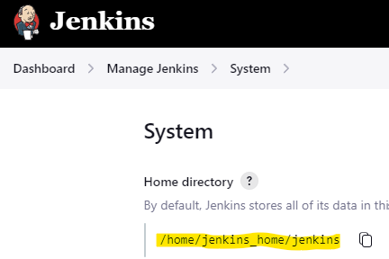

* The Home Directory path has been changed successfully.

1. **How to run Remote Job in Jenkins.**

We can trigger a job remotely through a Web URL in Jenkins also.

We will follow the below steps to achieve the same.

While configuring the job, we need to select Trigger builds remotely under Build Triggers, then we can give any authentication token eg new and Click Save.

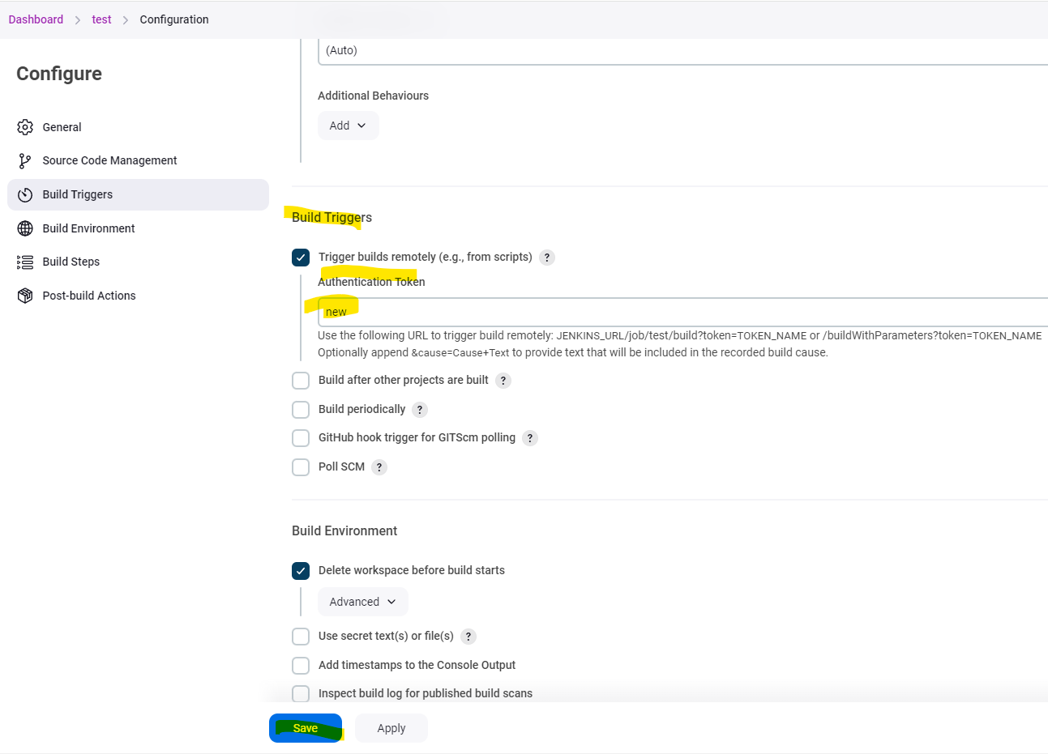

To trigger the build remotely we need use the below URL

JENKINS_URL/job/test/build?token=TOKEN_NAME or /buildWithParameters?token=TOKEN_NAME

Below screenshot is in our case



We see the 2nd Build is also executed successfully.

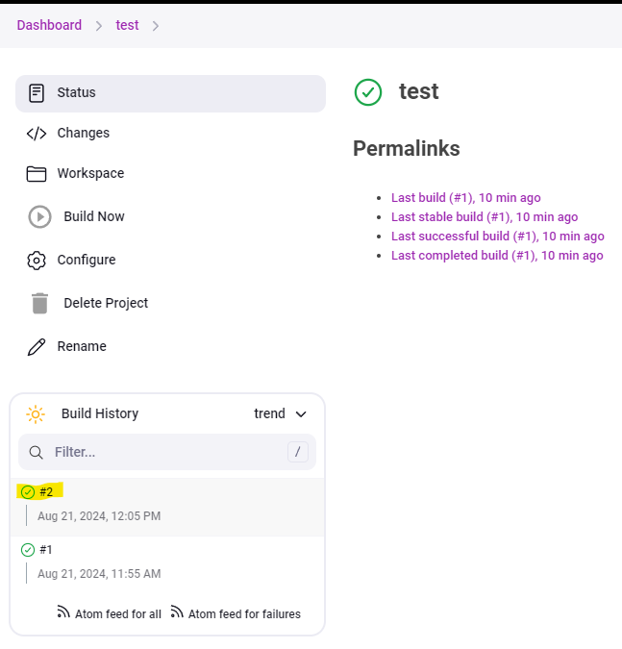

Alternate Way to run the job through remotely is by using a plugin

We need to install the plugin Build Authorization Token Root

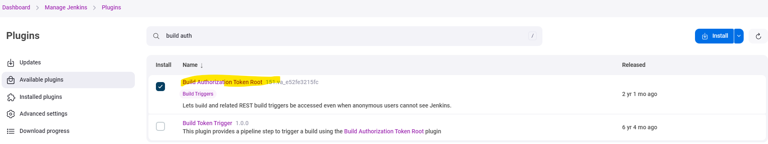

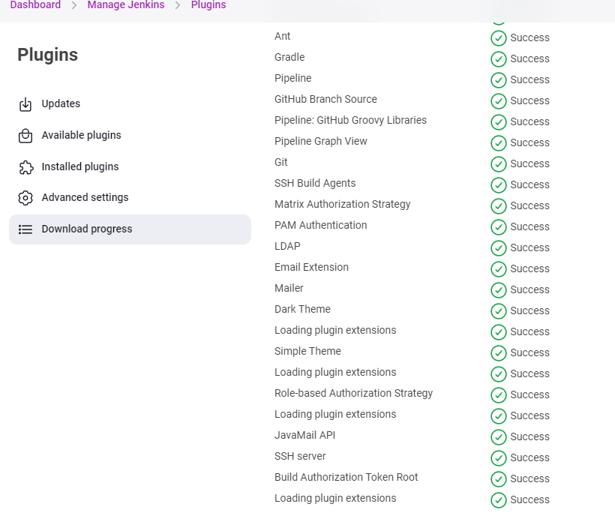

Now we will run the below URL to see if build runs.

<Jenkins_URL>buildByToken/build?job=<Job_Name>&token=<token Name>



See the Build 3 is also completed successfully.

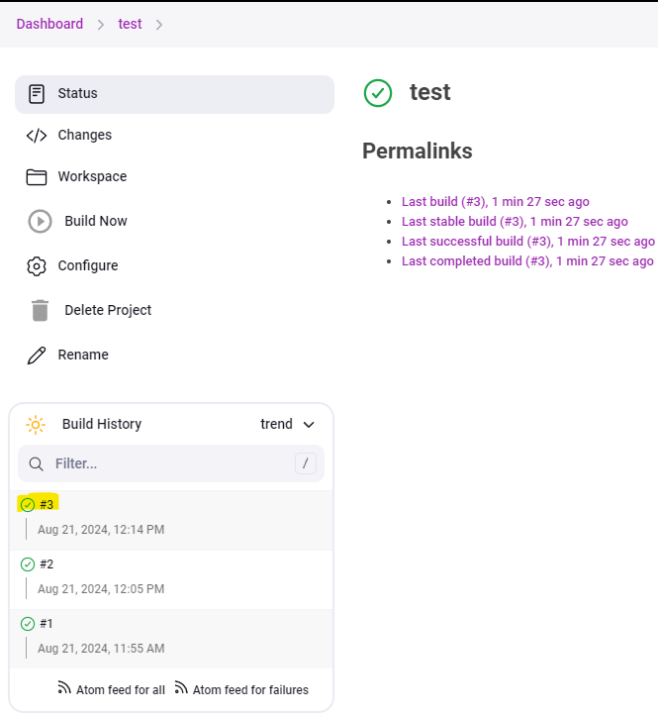

We can also run it on the Ubuntu terminal using the below command.

Just need to add “\” before the & and then run.

<Jenkins_URL>buildByToken/build?job=<Job_Name>\&token=<token Name>



Build 4 is completed successfully

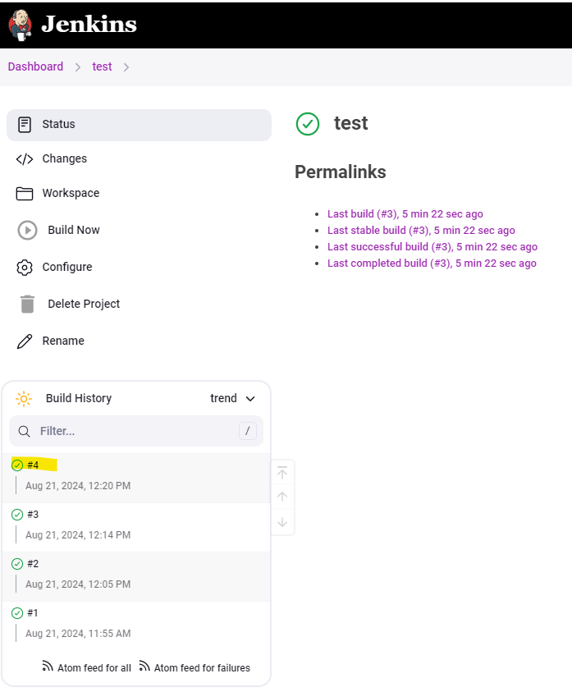

1. **How to create GitHub hook trigger for GITScm polling through Jenkins.**

This is used when a job needs to be triggered when there is any change in the GitHub repo.

Steps to followed are below:

While configuring the job, Check the option of GitHub hook trigger for GITScm polling under Build Triggers and then click Save.

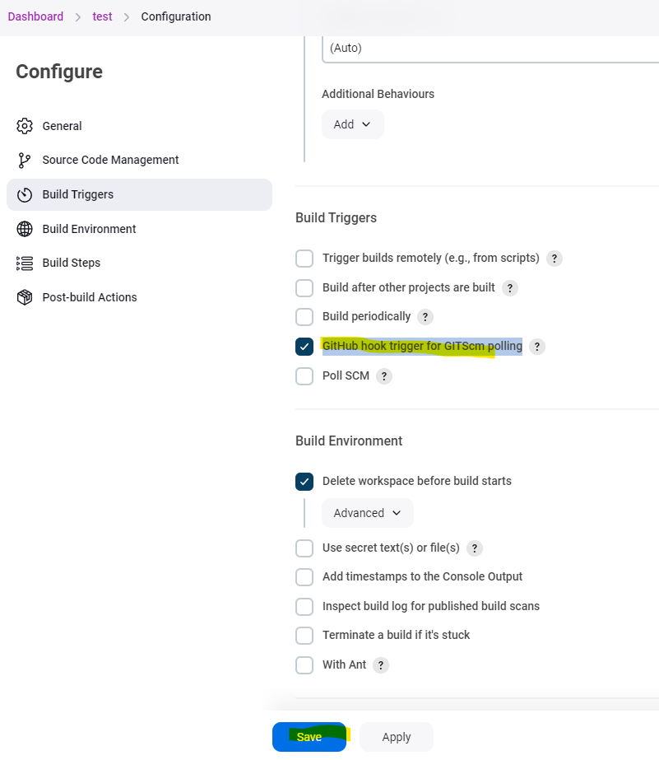

Then on the GitHub side, Go to Settings

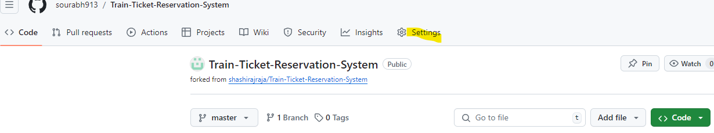

Select Webhooks > Add webhook

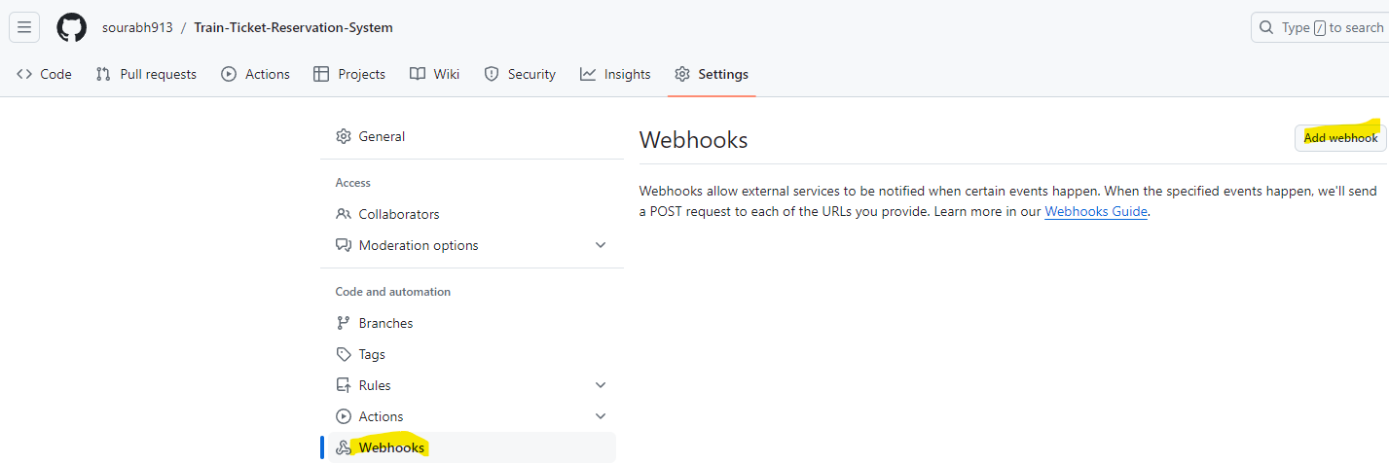

Need to put in password for your GitHub account.

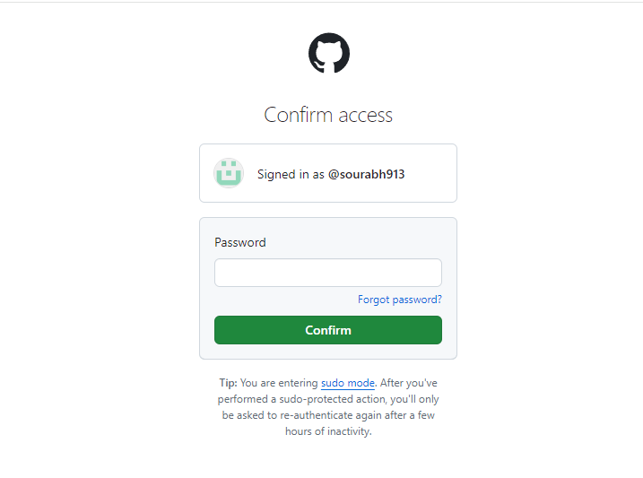

Then under the Payload URL, give the Jenkins URL /github webhook

And under Content type > Select application/json.

Click Add Webhook

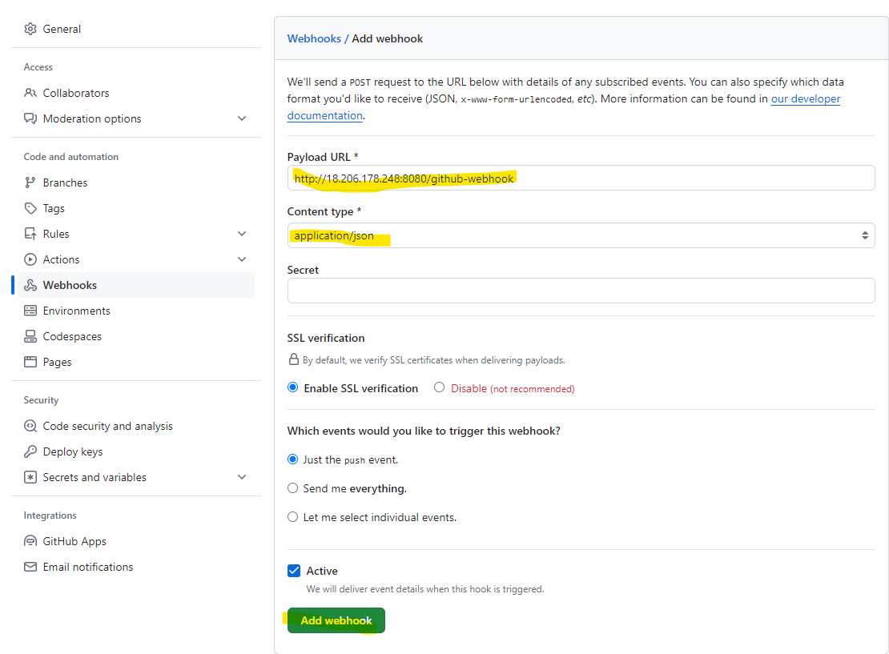

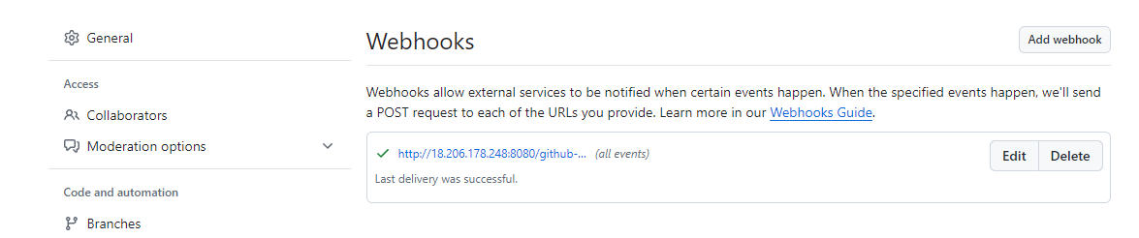

For Example, in my case I made a change under my repo > screenshots > rename viewprofila.png to viewprofile.png

Before Change

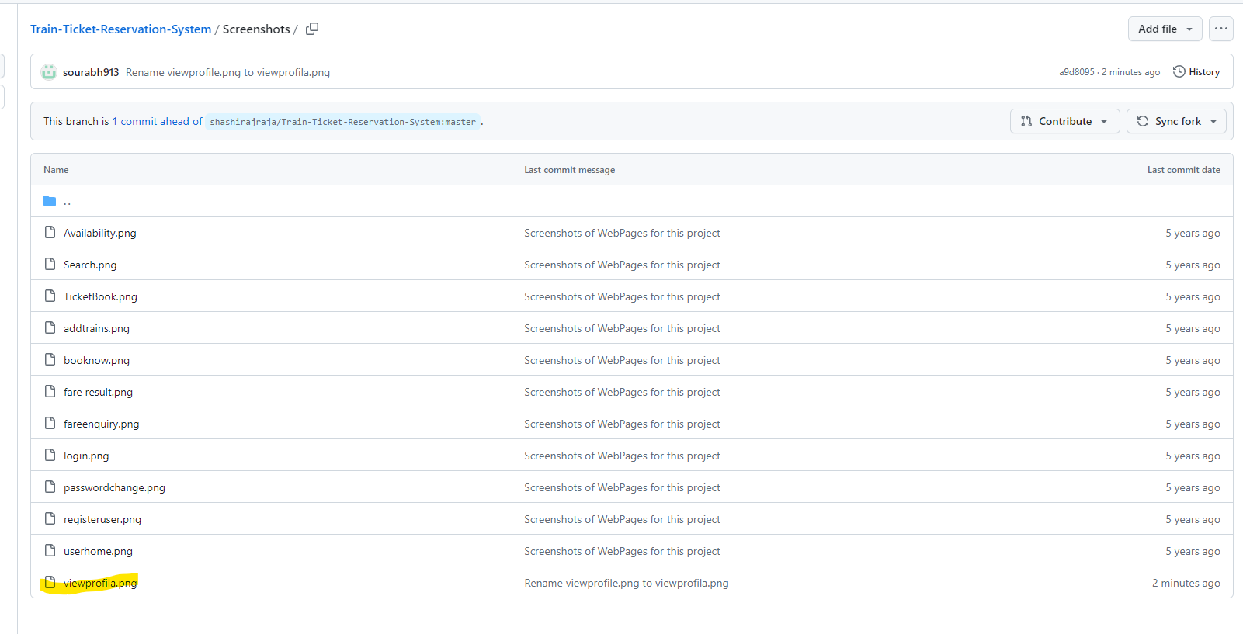

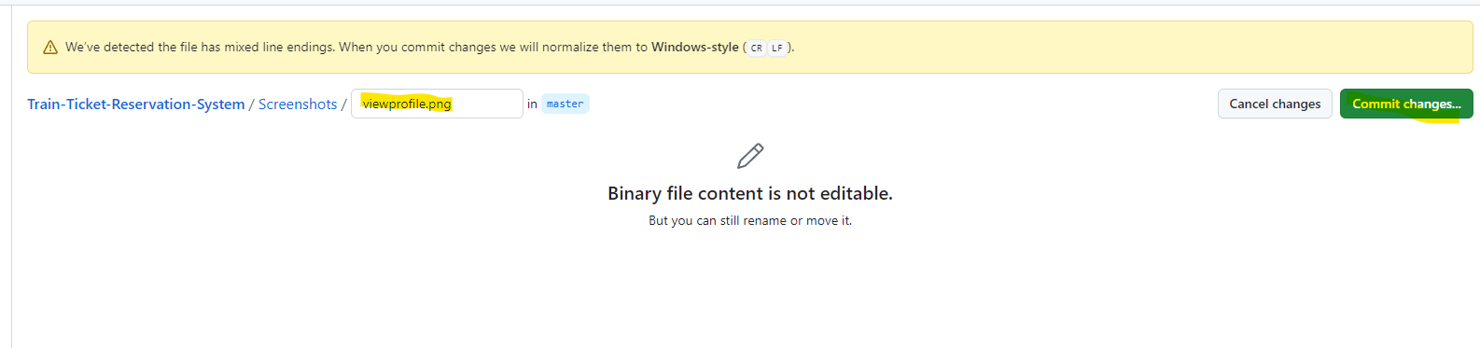

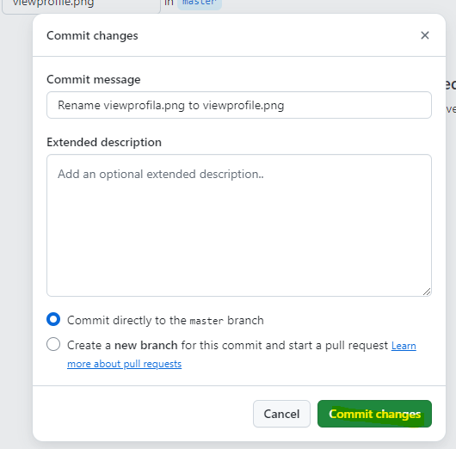

After Change

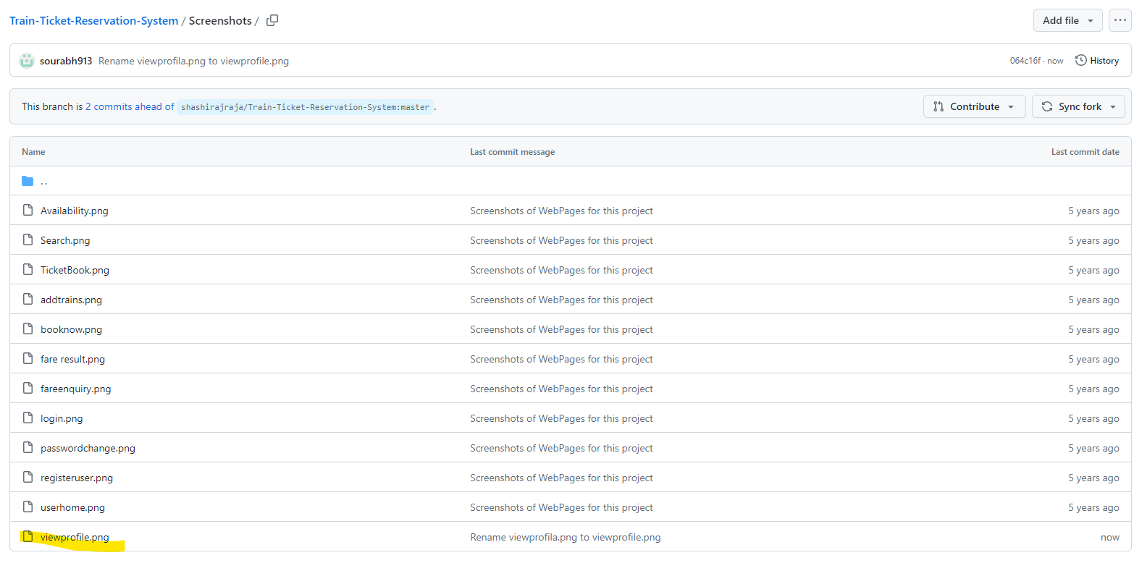

Immediately after the change, we see that build ran in Jenkins.

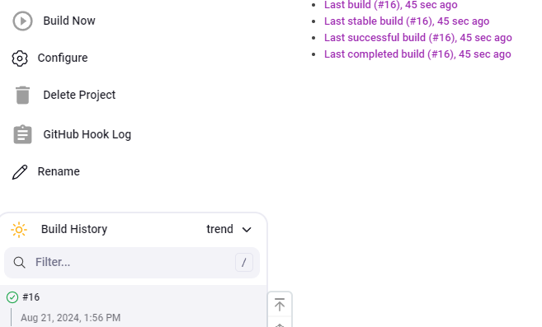

We can see the changes in the console output reflected successfully

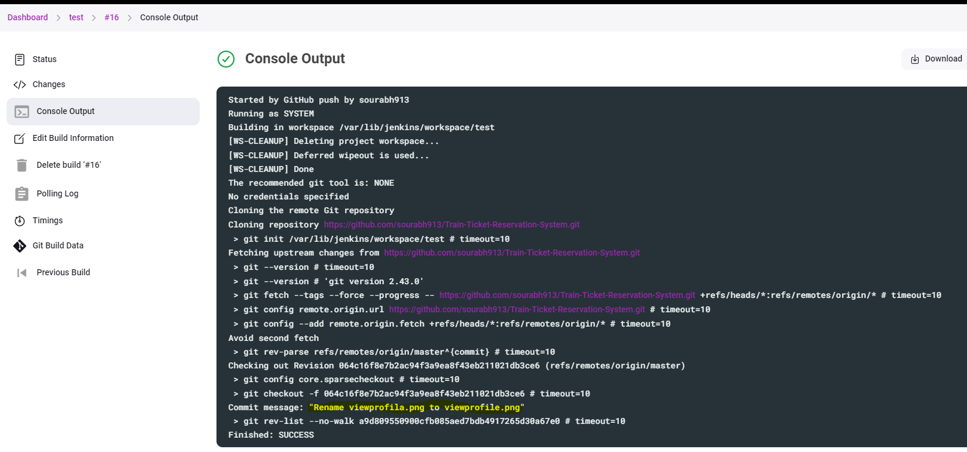

1. **How to install Jenkins in Tomcat.**

* To install jenkins in Tomcat, we need to have a EC2 instance with open-jdk installed on it.



Add the below commands in user data section of EC2 instance before launching it to install open-jdk on it.

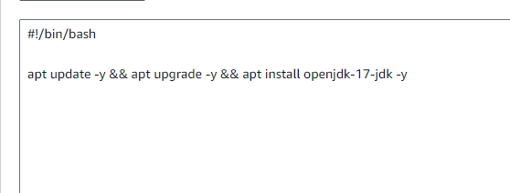

* Once EC2 is up, we will verify that OpenJDK is installed properly by checking its version.

java --version (Verify open jdk is installed)

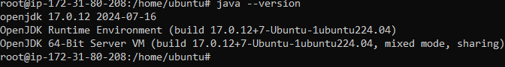

* Now we install Apache tomcat version 9 so that we can install jenkins on it.
* Since Tomcat version 9 is not available as default package in ubuntu so we have to install Tomcat 9 manually. Below are the steps to download and install tomcat 9.

wget <https://dlcdn.apache.org/tomcat/tomcat-9/v9.0.93/bin/apache-tomcat-9.0.93.tar.gz>

ls -ltr to check if the file is downloaded

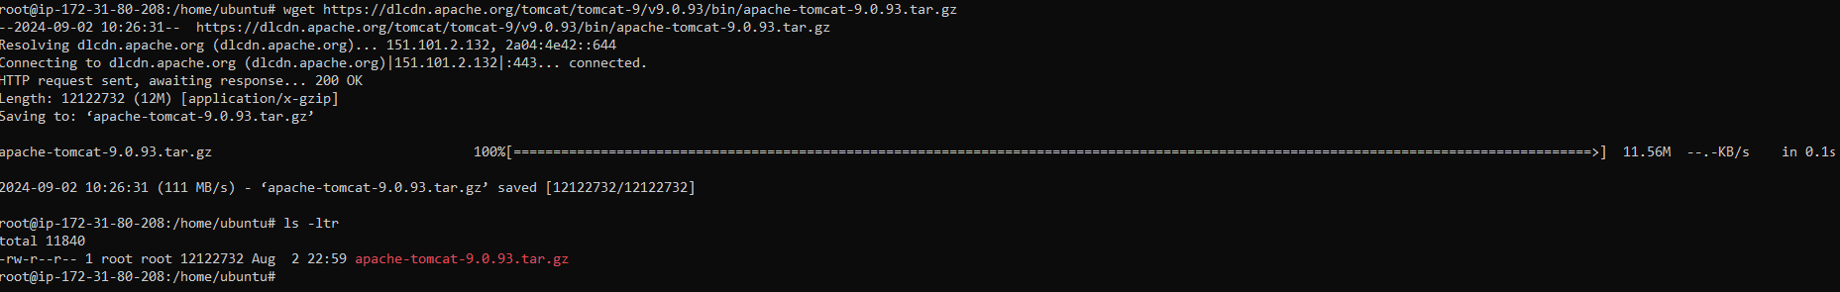

* Untar the tar file using below command and check tomcat folder is created or not.

tar xzvf apache-tomcat-9.0.93.tar.gz

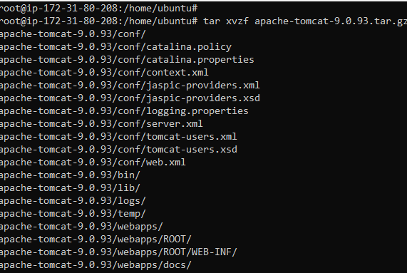

ls -ltr

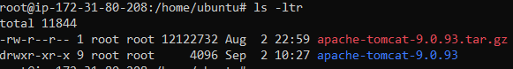

* Now rename the extracted folder tomcat so that it’s easy to remember and check.

mv apache-tomcat-9.0.93 tomcat

ls -ltr

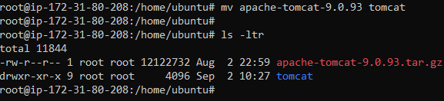

* Now we have to create the tomcat service manually in the system location mentioned below and add the contents in the service file.

vi /etc/systemd/system/tomcat.service



Contents of tomcat.service file

------------------------------------------

[Unit]

Description=Tomcat 9 servlet container

After=network.target

[Service]

Type=forking

Environment="JAVA_HOME=/usr/lib/jvm/java-17-openjdk-amd64"

Environment="JAVA_OPTS=-Djava.security.egd=file:///dev/urandom -Djava.awt.headless=true"

Environment="CATALINA_BASE=/home/ubuntu/tomcat/"

Environment="CATALINA_HOME=/home/ubuntu/tomcat/"

Environment="CATALINA_PID=/home/ubuntu/tomcat/temp/tomcat.pid"

Environment="CATALINA_OPTS=-Xms512M -Xmx1024M -server -XX:+UseParallelGC"

ExecStart=/home/ubuntu/tomcat/bin/startup.sh

ExecStop=/home/ubuntu/tomcat/bin/shutdown.sh

[Install]

WantedBy=multi-user.target

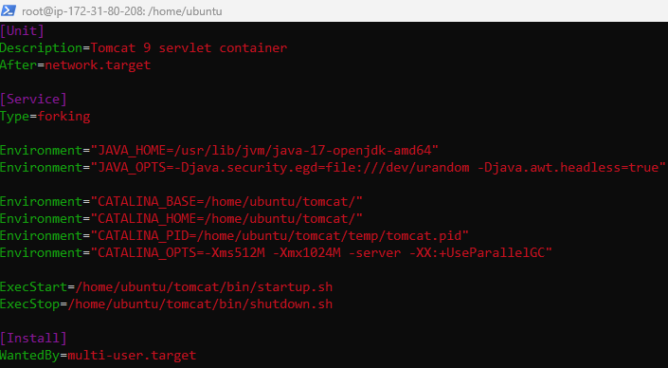

* Now we will reload the daemon and start tomcat service and also verify that the service is running.

systemctl daemon-reload

systemctl start tomcat

systemctl status tomcat

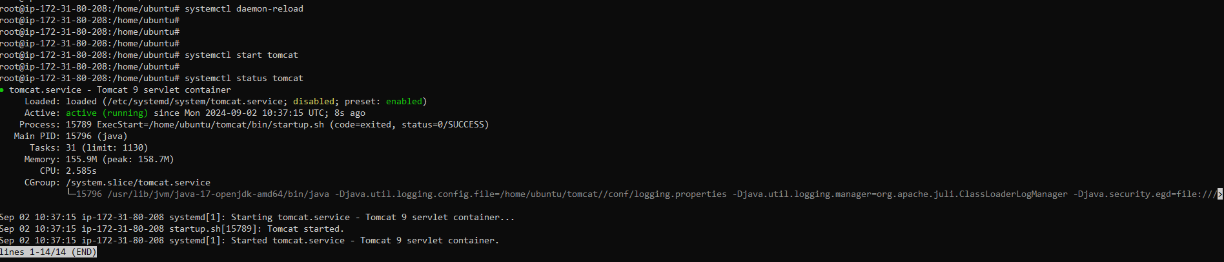

* We will verify that tomcat is running or not on the WEG UI by accessing tomcat URL – PublicIP of EC2 instance:8080 (Tomcat works on port 8080)

<http://3.89.226.233:8080>

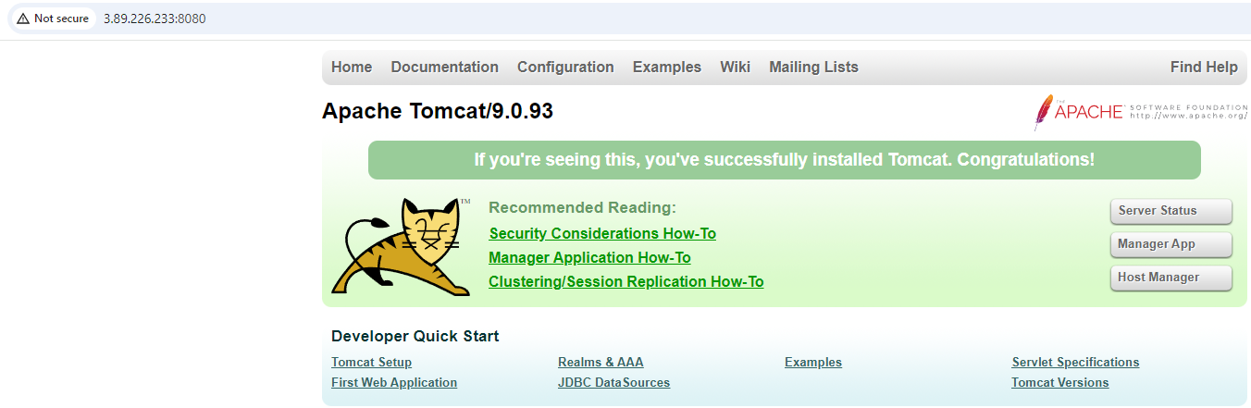

* Once we have apache tomcat 9 up and running, we will download jenkins.war file from the official webpage from the terminal by running the below command.

wget <http://mirrors.jenkins.io/war-stable/latest/jenkins.war>

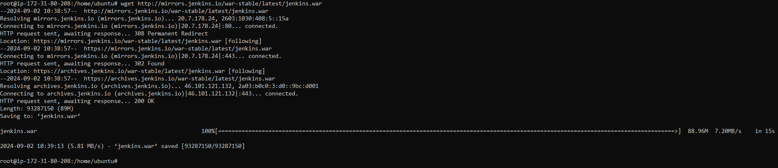

ls -ltr

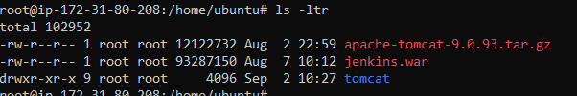

* Now we need to copy this file to webapps directory located in Tomcat home. So, if you have tomcat installed in home directory, then run the following command.

cp -rv jenkins.war tomcat/webapps

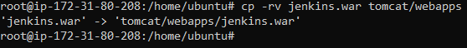

* We will also verify that jenkins.war has been copied successfully and also jenkins folder is also created.

ls -ltr tomcat/webapps

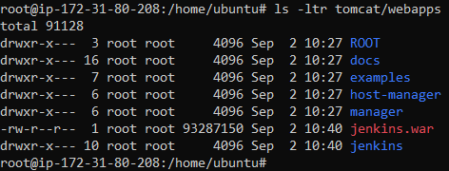

* Since our tomcat server is up. To start using the jenkins, we will visit the following URL.

<http://3.89.226.233:8080/jenkins>

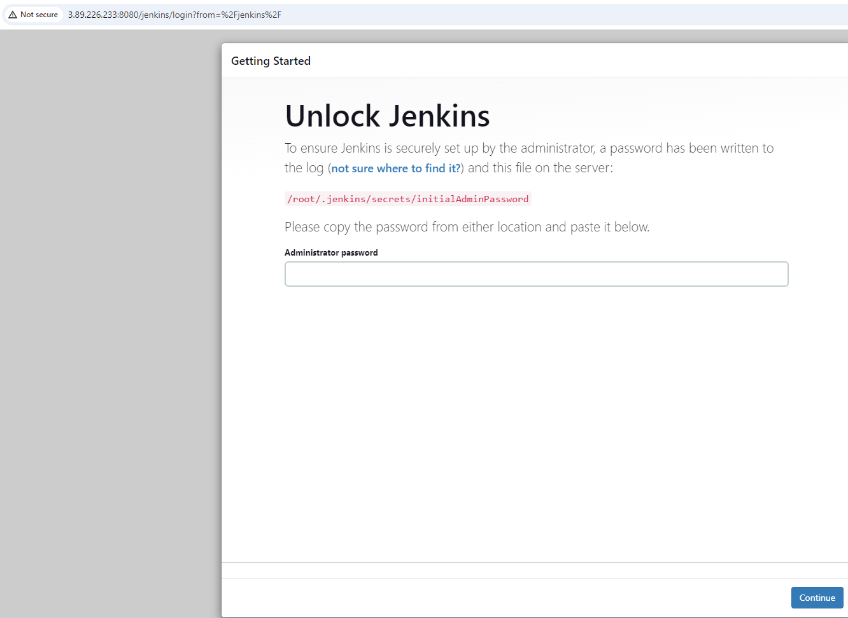

* We will have to configure the jenkins server now. As mentioned on the webpage, we can find the admin password from location ‘/root/.jenkins/secrets/initialAdminPassword’ . Get the password with the command,

cat /root/.jenkins/secrets/initialAdminPassword



* Now complete the setup by filling out the required details. After the setup is complete, we can access jenkins & can also create new jobs on the jenkins server.

1. **Install old version of Jenkins and then upgrade it to a latest version**

* To install old version of jenkins, we need to have a EC2 instance with open-jdk installed on it.
* Add the below commands in user data section of EC2 instance before launching it to install open-jdk on it.



* Once EC2 is up, we will verify that OpenJDK is installed properly by checking its version.

java --version (Verify open jdk is installed)

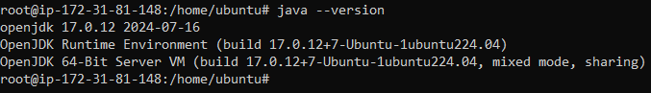

* Now we will prepare the system for jenkins in ubuntu by executing the following command.
* Below is the Debian package repository of Jenkins to automate installation and upgrade. To use this repository, first add the key to your system

wget -O /usr/share/keyrings/jenkins-keyring.asc \

<https://pkg.jenkins.io/debian-stable/jenkins.io-2023.key>

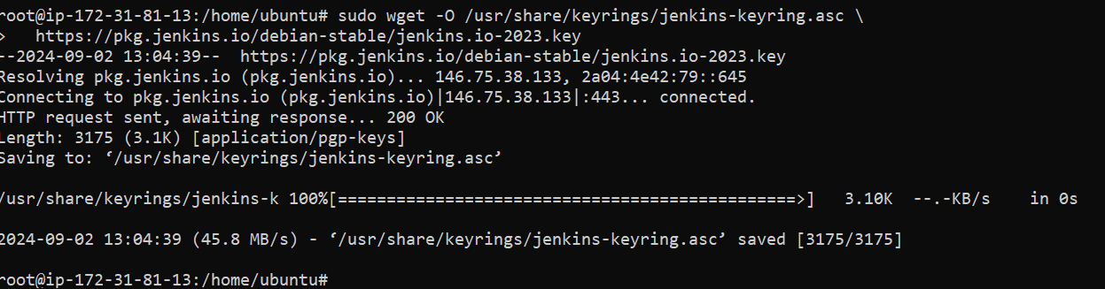

* Add a Jenkins apt repository entry:

echo "deb [signed-by=/usr/share/keyrings/jenkins-keyring.asc]" \

https://pkg.jenkins.io/debian-stable binary/ | sudo tee \

/etc/apt/sources.list.d/jenkins.list > /dev/null



apt-get update

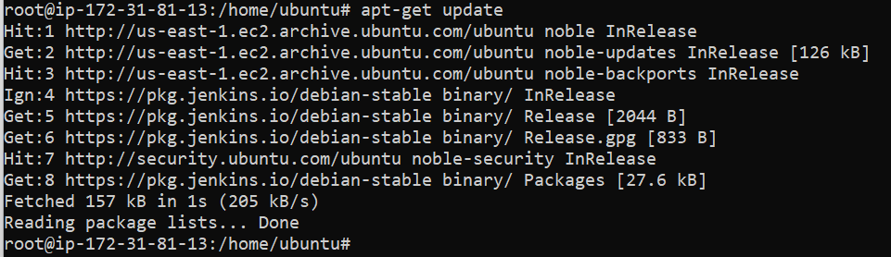

* Now we will check which all versions of Jenkins are available, so that we can install and old version and then perform an upgrade to the latest version. Below is the command for the same. (It will give all the versions starting from the oldest to the latest.

apt-cache madison jenkins

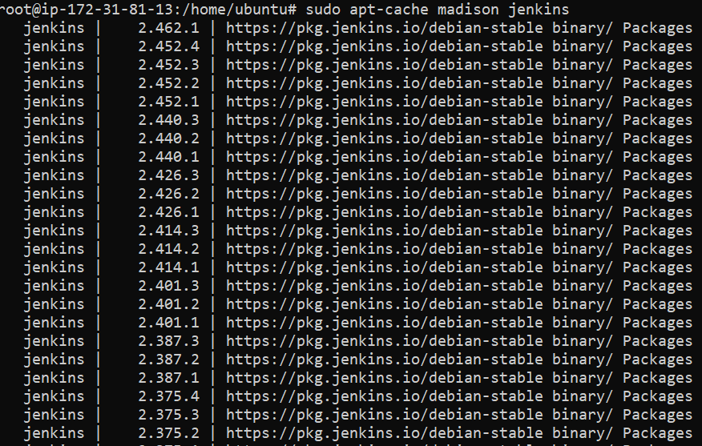

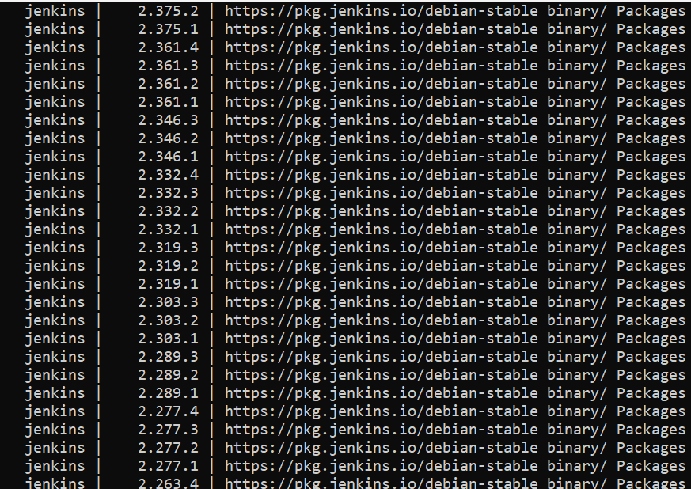

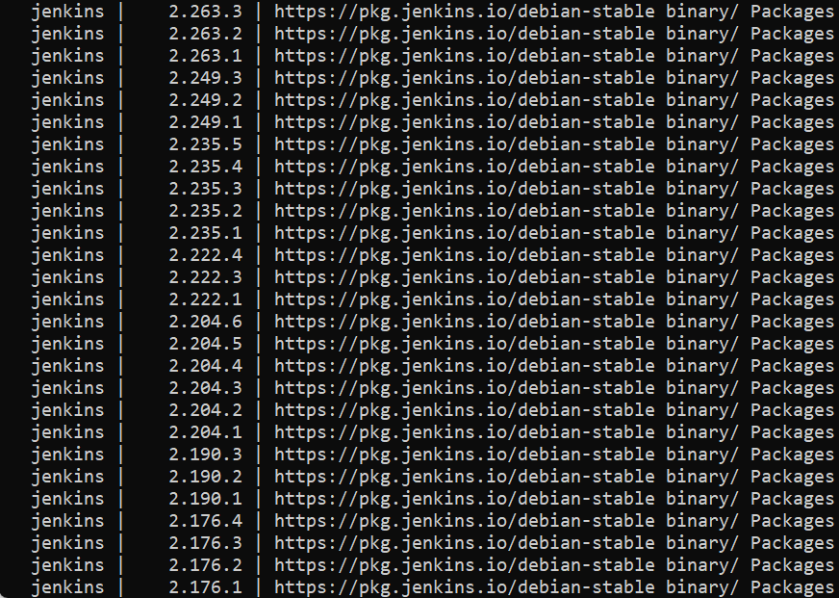

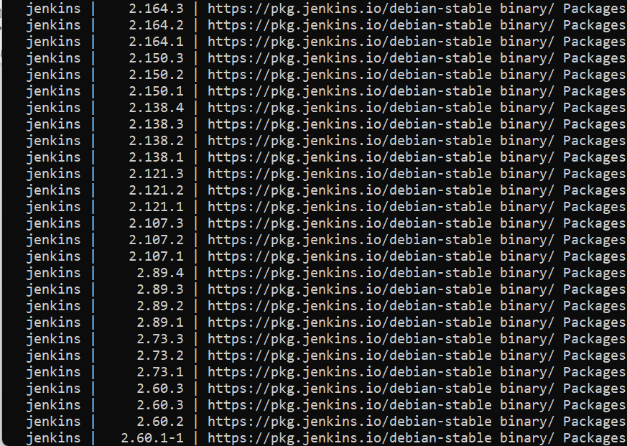

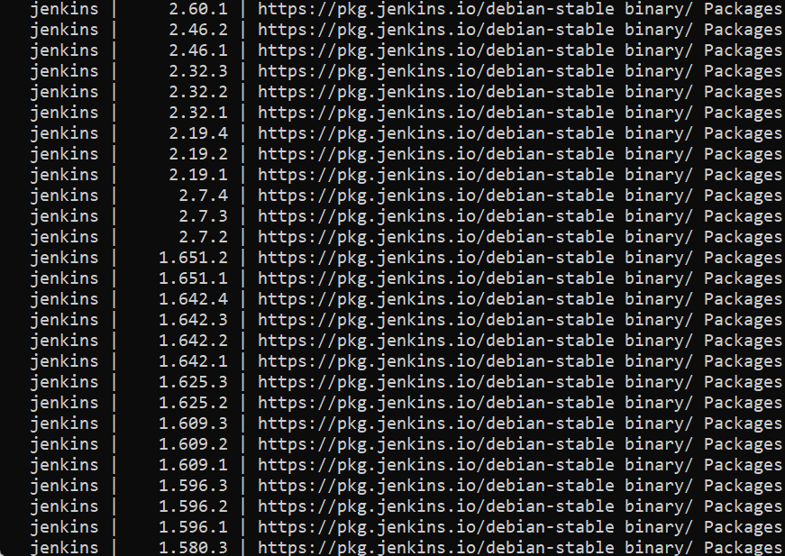

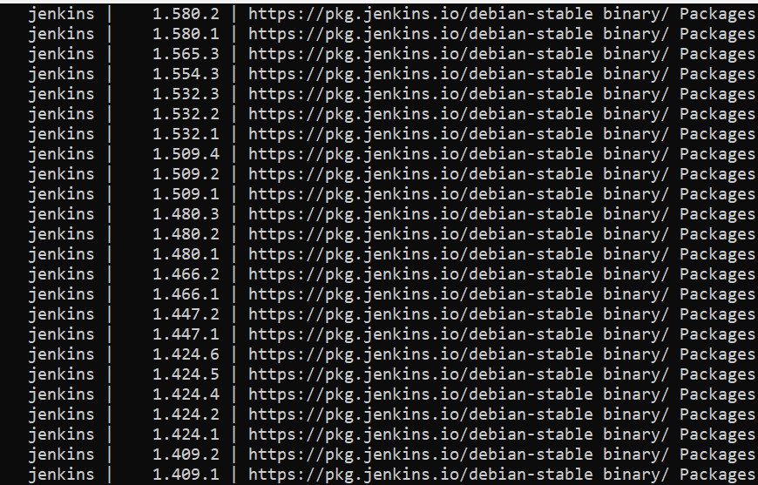

* Here we have randomly selected a version to install i.e. 2.387.3. To install the specific jenkins version, we need to run the below command.

apt-get install jenkins=2.387.3 -y

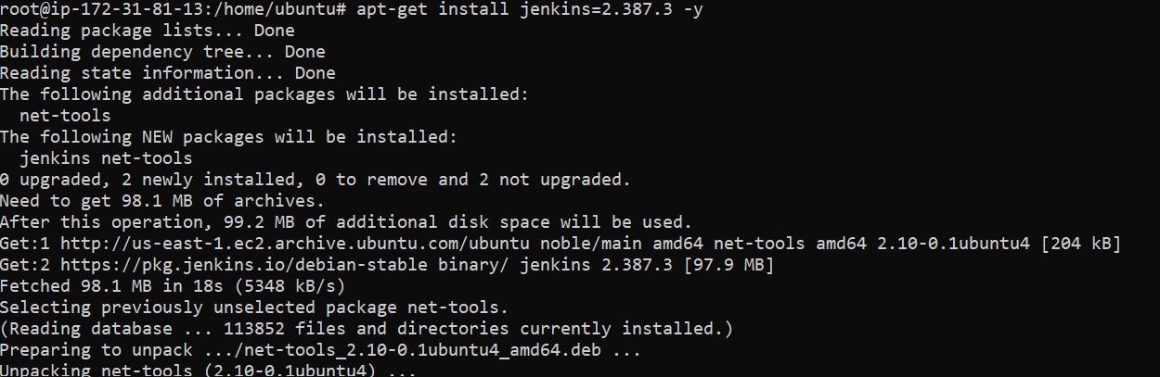

* We can see in the below screenshot that Jenkins 2.387.3 version is installed.

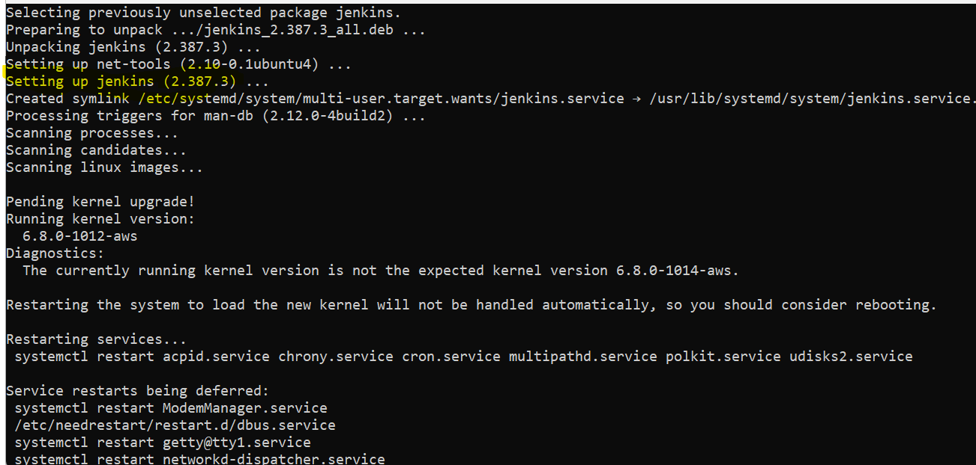

* Check status of Jenkins service.

systemctl status jenkins

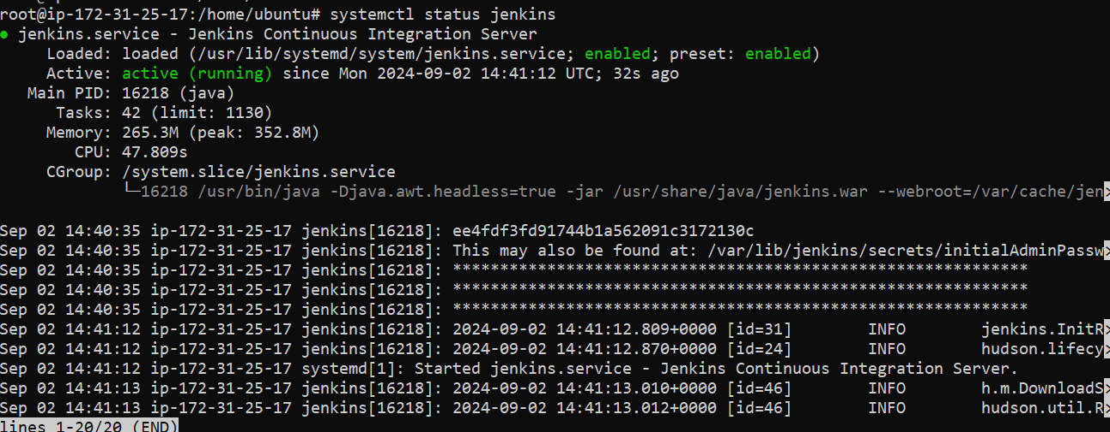

* We will verify that jenkins server is up and running and perform post deployment steps

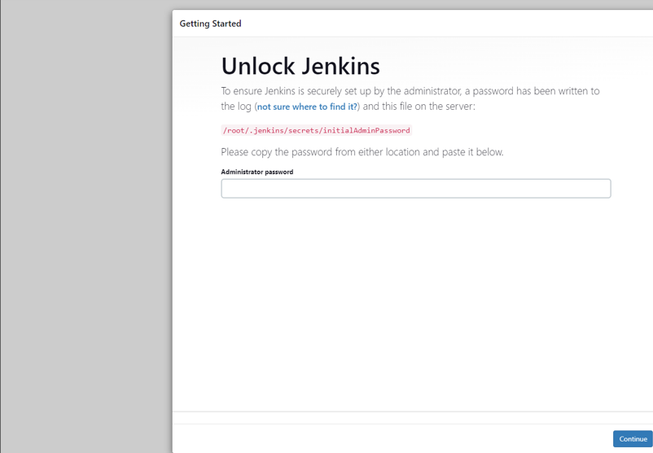

* Once the EC2 instance is up, Post deployment steps are performed for configuring Jenkins to setup the Jenkins server. Once Jenkins is configured, we see the below dashboard screen and below screenshot will give you the confirmation of version 2.387.3 jenkins setup.

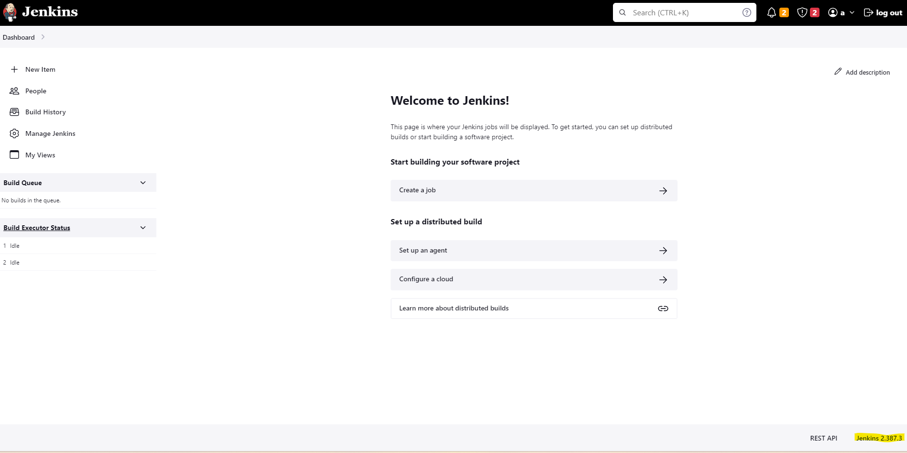

* Before upgrading to the latest version, we need to stop jenkins service by using the below command.

systemctl stop jenkins



* Once the jenkins service is stopped, we will upgrade this version 2.387.3 to the latest version i.e. 2.462.1, by running the below command on the terminal. Below screenshot shows latest version is setting up.

apt-get upgrade -y

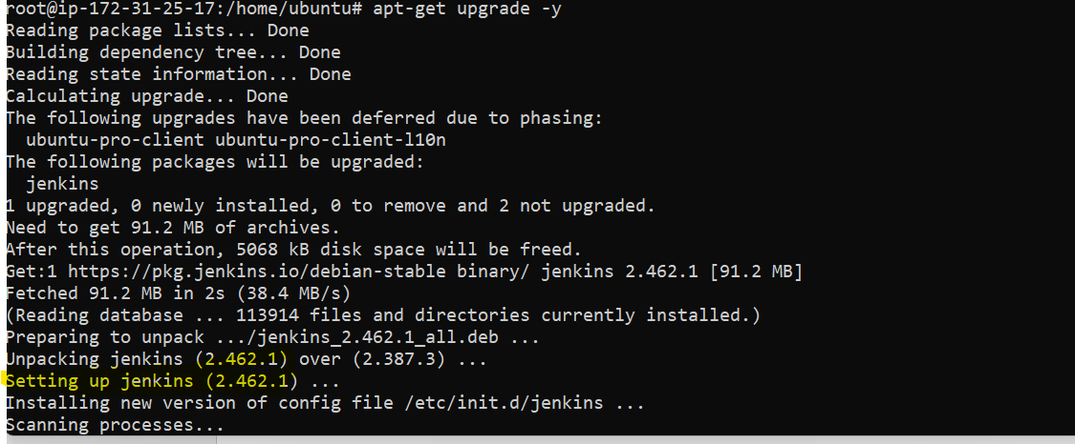

* Now we will verify the version is updated successfully by logging into the jenkins console again. Below screenshot confirms the same.

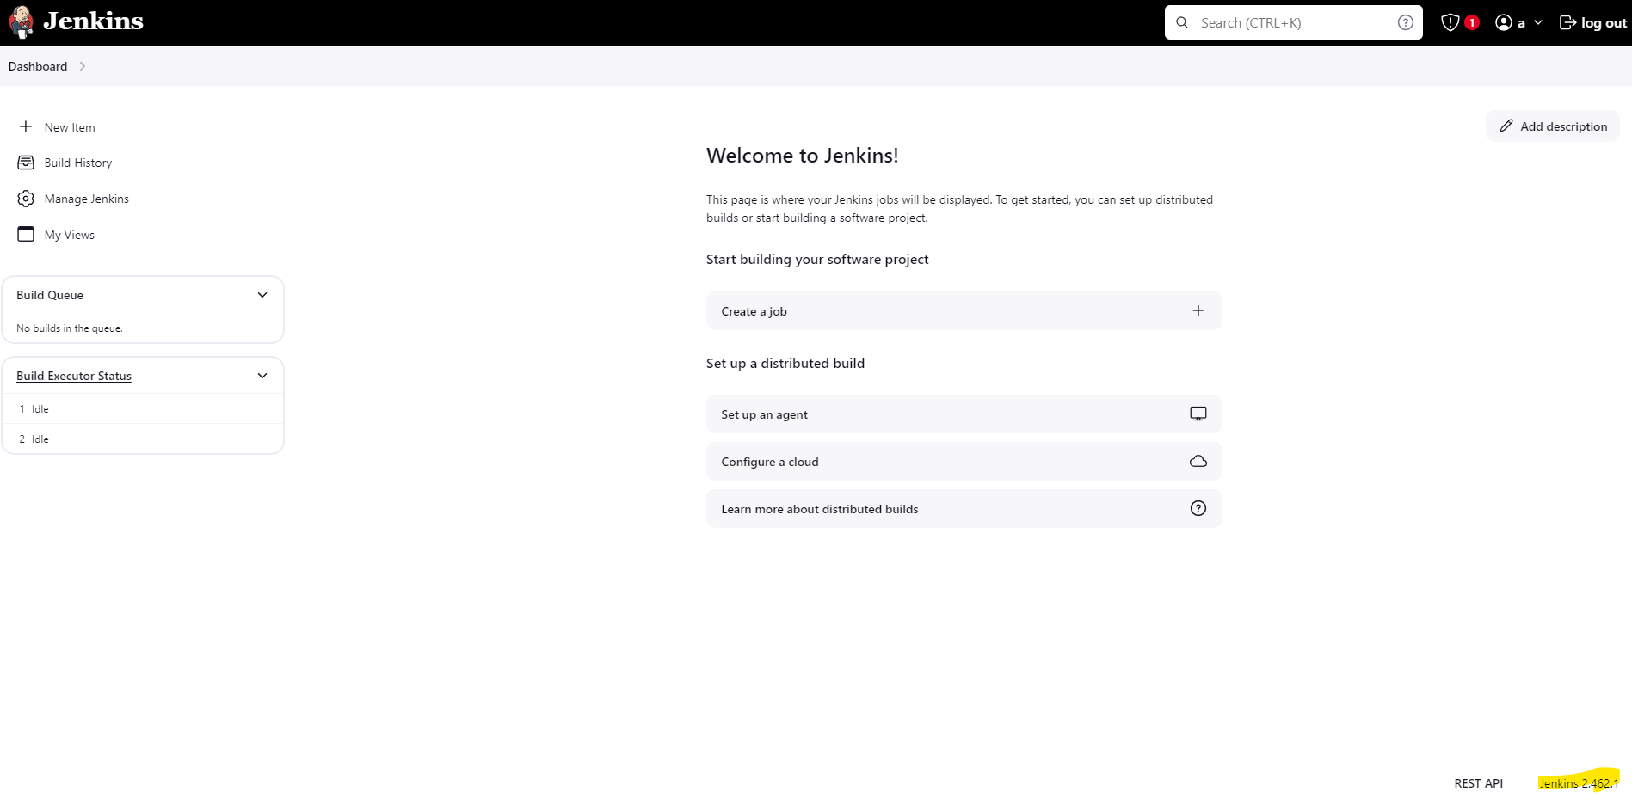

1. **Jenkins Installation and Configuration Script**

* Jenkins installation and configuration script is broken down into three components.
* Jenkins Installation
* Create Admin User
* Installation of recommended plugins
* Confirming Jenkins URL
* Jenkins installation script is as below:

#!/bin/bash

#JENKINS INSTALLATION

# Update and Upgrade Packages of Ubuntu OS

sudo apt update -y && sudo apt upgrade -y

#Install Java SDK 17

sudo apt install openjdk-17-jdk -y

# Check Java version

java -version

# Add Jenkins repository key

sudo wget -O /usr/share/keyrings/jenkins-keyring.asc \

<https://pkg.jenkins.io/debian-stable/jenkins.io-2023.key>

# Add Jenkins repository to sources list

echo "deb [signed-by=/usr/share/keyrings/jenkins-keyring.asc]" \

https://pkg.jenkins.io/debian-stable binary/ | sudo tee \

/etc/apt/sources.list.d/jenkins.list > /dev/null

# Update package lists

sudo apt-get update

# Install Jenkins

sudo apt-get install jenkins -y

#Start Jenkins

sudo systemctl start jenkins

# Enable Jenkins to run on Boot

sudo systemctl enable jenkins

* Jenkins create admin user script is as below: Highlighted items in below script will be changed according to your requirements

#! /bin/bash

#JENKINS ADMIN USER CREATION

# Install python3-pip (Prerequisite)

sudo apt install python3-pip -y

# Install Dev Packages of Python (Prerequisite)

sudo apt install -y build-essential libssl-dev libffi-dev python3-dev

url=<Jenkins URL> (e.g. http://52.91.81.96:8080)

password=$(sudo cat /var/lib/jenkins/secrets/initialAdminPassword)

# NEW ADMIN CREDENTIALS URL ENCODED USING PYTHON

username=$(python3 -c "import urllib.parse;print (urllib.parse.quote(input(), safe=''))" <<< "user")

new_password=$(python3 -c "import urllib.parse;print (urllib.parse.quote(input(), safe=''))" <<< "password")

fullname=$(python3 -c "import urllib.parse;print (urllib.parse.quote(input(), safe=''))" <<< "full name")

email=$(python3 -c "import urllib.parse;print (urllib.parse.quote(input(), safe=''))" <<< "hello@world.com")

# GET THE CRUMB AND COOKIE

cookie_jar="$(mktemp)"

full_crumb=$(curl -u "admin:$password" --cookie-jar "$cookie_jar" $url/crumbIssuer/api/xml?xpath=concat\(//crumbRequestField,%22:%22,//crumb\))

arr_crumb=(${full_crumb//:/ })

only_crumb=$(echo ${arr_crumb[1]})

# MAKE THE REQUEST TO CREATE AN ADMIN USER

curl -X POST -u "admin:$password" $url/setupWizard/createAdminUser \

-H "Connection: keep-alive" \

-H "Accept: application/json, text/javascript" \

-H "X-Requested-With: XMLHttpRequest" \

-H "$full_crumb" \

-H "Content-Type: application/x-www-form-urlencoded" \

--cookie $cookie_jar \

--data-raw "username=$username&password1=$new_password&password2=$new_password&fullname=$fullname&email=$email&Jenkins-Crumb=$only_crumb&json=%7B%22username%22%3A%20%22$username%22%2C%20%22password1%22%3A%20%22$new_password%22%2C%20%22%24redact%22%3A%20%5B%22password1%22%2C%20%22password2%22%5D%2C%20%22password2%22%3A%20%22$new_password%22%2C%20%22fullname%22%3A%20%22$fullname%22%2C%20%22email%22%3A%20%22$email%22%2C%20%22Jenkins-Crumb%22%3A%20%22$only_crumb%22%7D&core%3Aapply=&Submit=Save&json=%7B%22username%22%3A%20%22$username%22%2C%20%22password1%22%3A%20%22$new_password%22%2C%20%22%24redact%22%3A%20%5B%22password1%22%2C%20%22password2%22%5D%2C%20%22password2%22%3A%20%22$new_password%22%2C%20%22fullname%22%3A%20%22$fullname%22%2C%20%22email%22%3A%20%22$email%22%2C%20%22Jenkins-Crumb%22%3A%20%22$only_crumb%22%7D"

* Jenkins install recommended plugin script is as below:

#!bin/bash

#INSTALLATION OF RECOMMENDED PLUGINS IN JENKINS

url=<jenkins URL> (e.g. http://52.91.81.96:8080)

#ENTER THE CREDENTIALS HIGHLIGHTED IN THE ABOVE CODE

user=user

password=password

cookie_jar="$(mktemp)"

full_crumb=$(curl -u "$user:$password" --cookie-jar "$cookie_jar" $url/crumbIssuer/api/xml?xpath=concat\(//crumbRequestField,%22:%22,//crumb\))

arr_crumb=(${full_crumb//:/ })

only_crumb=$(echo ${arr_crumb[1]})

# MAKE THE REQUEST TO DOWNLOAD AND INSTALL REQUIRED MODULES

curl -X POST -u "$user:$password" $url/pluginManager/installPlugins \

-H 'Connection: keep-alive' \

-H 'Accept: application/json, text/javascript, */*; q=0.01' \

-H 'X-Requested-With: XMLHttpRequest' \

-H "$full_crumb" \

-H 'Content-Type: application/json' \

-H 'Accept-Language: en,en-US;q=0.9,it;q=0.8' \

--cookie $cookie_jar \

--data-raw "{'dynamicLoad':true,'plugins':['cloudbees-folder','antisamy-markup-formatter','build-timeout','credentials-binding','timestamper','ws-cleanup','ant','gradle','workflow-aggregator','github-branch-source','pipeline-github-lib','pipeline-stage-view','git','ssh-slaves','matrix-auth','pam-auth','ldap','email-ext','mailer'],'Jenkins-Crumb':'$only_crumb'}"

* Confirming Jenkins URL script is as below:

#!/bin/bash

#CONFIRMING JENKINS URL

url=<your_jenkins_url> (e.g. http://52.91.81.96:8080)

user=user

password=password

url_urlEncoded=$(python3 -c "import urllib.parse;print (urllib.parse.quote(input(), safe=' '))" <<< "$url")

cookie_jar="$(mktemp)"

full_crumb=$(curl -u "$user:$password" --cookie-jar "$cookie_jar" $url/crumbIssuer/api/xml?xpath=concat\(//crumbRequestField,%22:%22,//crumb\))

arr_crumb=(${full_crumb//:/ })

only_crumb=$(echo ${arr_crumb[1]})

curl -X POST -u "$user:$password" $url/setupWizard/configureInstance \

  -H 'Connection: keep-alive' \

  -H 'Accept: application/json, text/javascript, */*; q=0.01' \

  -H 'X-Requested-With: XMLHttpRequest' \

  -H "$full_crumb" \

  -H 'Content-Type: application/x-www-form-urlencoded' \

  -H 'Accept-Language: en,en-US;q=0.9,it;q=0.8' \

  --cookie $cookie_jar \

  --data-raw "rootUrl=$url_urlEncoded%2F&Jenkins-Crumb=$only_crumb&json=%7B%22rootUrl%22%3A%20%22$url_urlEncoded%2F%22%2C%20%22Jenkins-Crumb%22%3A%20%22$only_crumb%22%7D&core%3Aapply=&Submit=Save&json=%7B%22rootUrl%22%3A%20%22$url_urlEncoded%2F%22%2C%20%22Jenkins-Crumb%22%3A%20%22$only_crumb%22%7D"

**NOTE:** [**https://kevin-denotariis.medium.com/download-install-and-setup-jenkins-completely-from-bash-unlock-create-admin-user-and-more-debd3320414a**](https://kevin-denotariis.medium.com/download-install-and-setup-jenkins-completely-from-bash-unlock-create-admin-user-and-more-debd3320414a) **(Script Reference, You can refer the above link for detail explanation)**

1. **How to take backup in Jenkins and Restore.**

* To perform the backup of Jenkins and Restore the backup on other machine, we need to install/perform following prerequisites:
* Need to have two AWS EC2 instance of Jenkins.
* First Jenkins will be the primary one where we will create jobs and there will build history and all and we will take the backup of this server which will include jobs, configs and all.
* Second Jenkins will be the backup one, which will be simple jenkins installed instance with default settings and all and this instance will be used to restore the backup of the first Jenkins server.
* Need to have S3 bucket created which will be used to store the jenkins backup and also will be used for restore.
* IAM role for S3 full access, this role is required so that we can upload the backup on S3 bucket from first Jenkins instance and also download backup to restore on second Jenkins instance.
* We need have aws cli installed using python on both the jenkins instances so that we can run the commands to upload to S3 bucket and download from the S3 bucket.
* **Now will setup the first jenkins instance. In our case below is the first server.**



* We will get the default admin password and put on the below screen.

NOTE: Make a note of default password

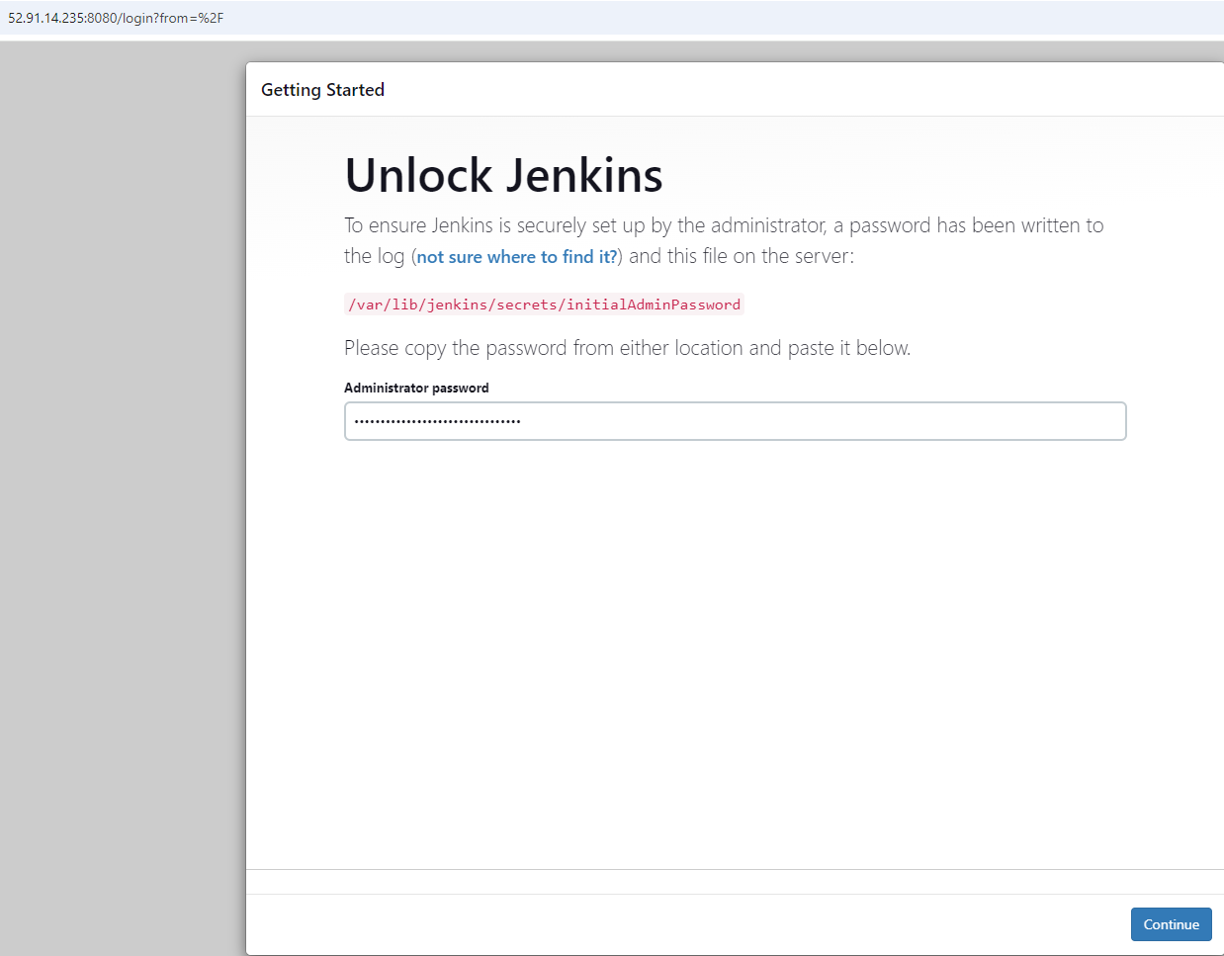

* We will install suggested plugins

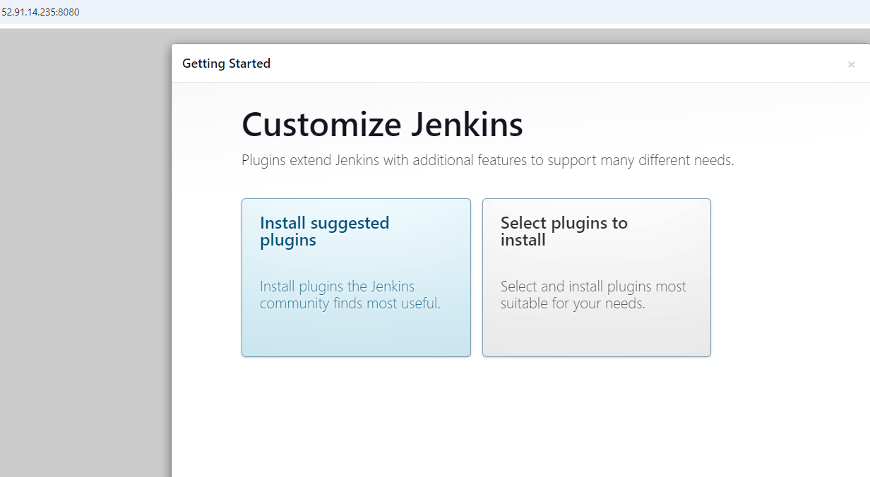

* We will skip the next screen and continue as admin

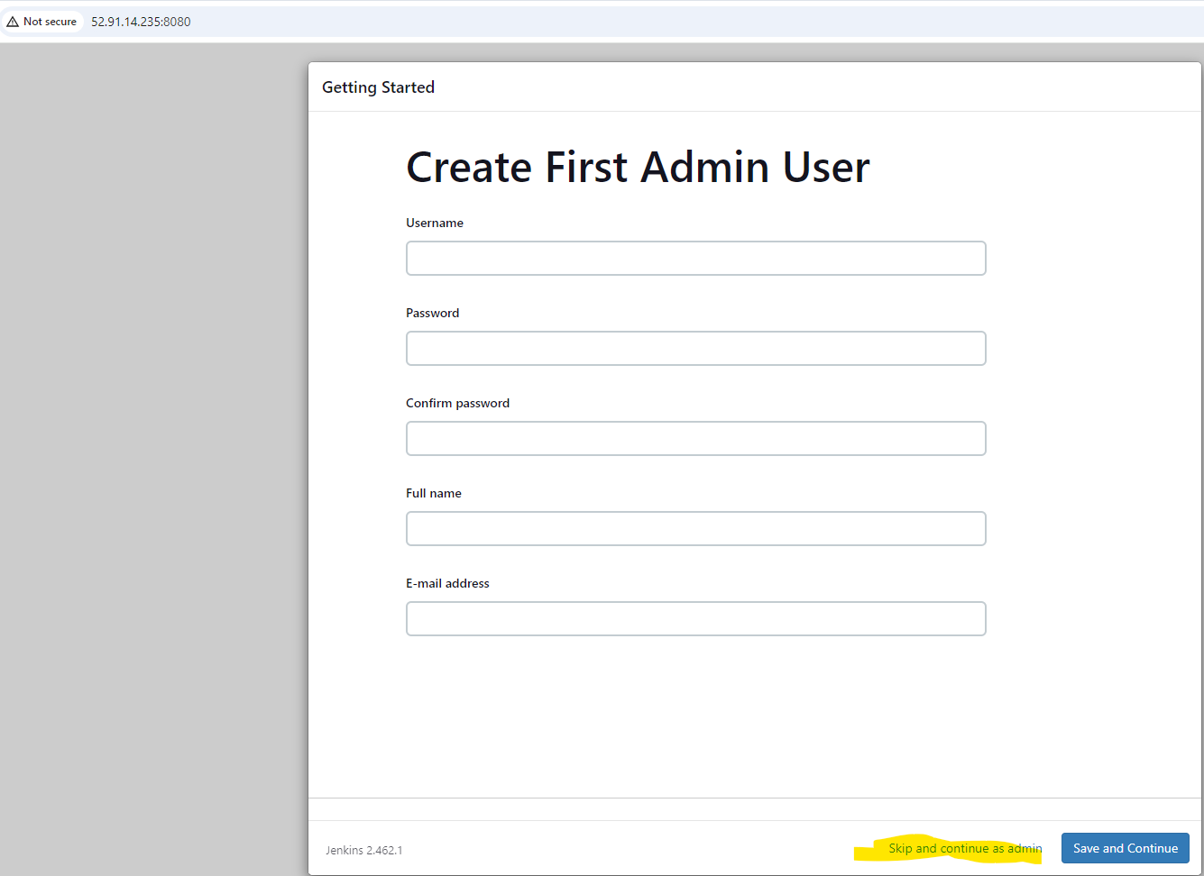

* Verify Jenkins URL and start using Jenkins.
* Now we will change the admin password as per our convenience by dropping down on the admin > Configure

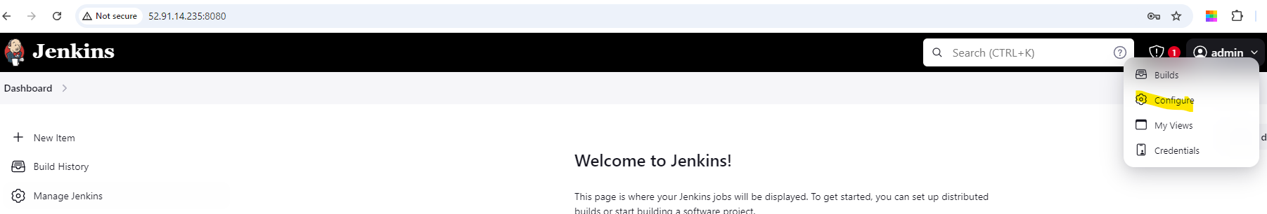

* Change the password at the location mentioned in the below screenshot and click Apply and Save

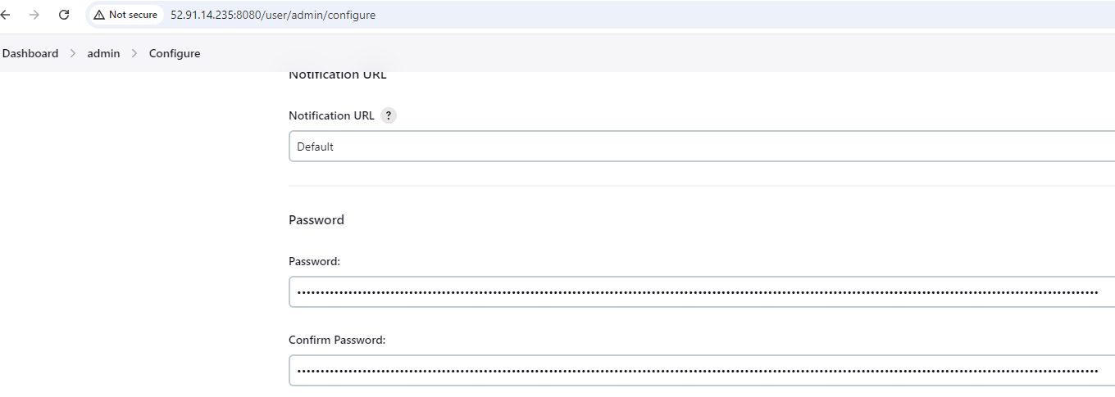

* Below Screen will appear

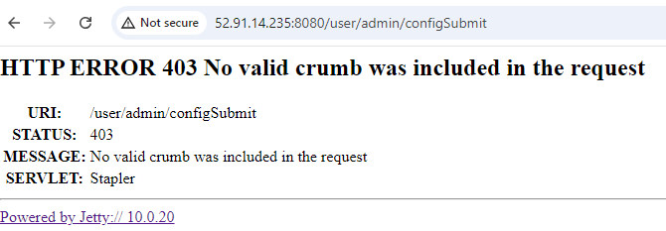

* Now login to admin user with the new credentials and verify the password change

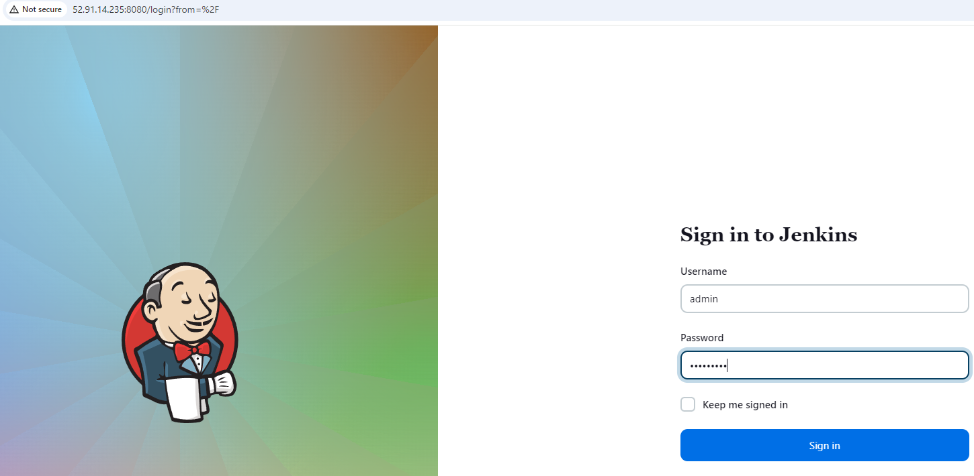

* You should be able to get in with new credentials.
* Now we will create two jobs so that we have some data is there which we can backup.
* Job 1 is freestyle project and below are the configurations.

General > Description > Job1

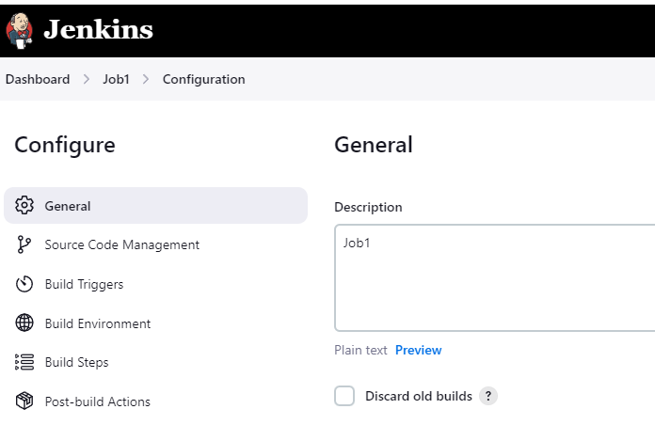

* Build Steps > Execute Shell >Command

echo "Jenkins-Primary"

echo " Hello All"

more /etc/os-release

pwd

date

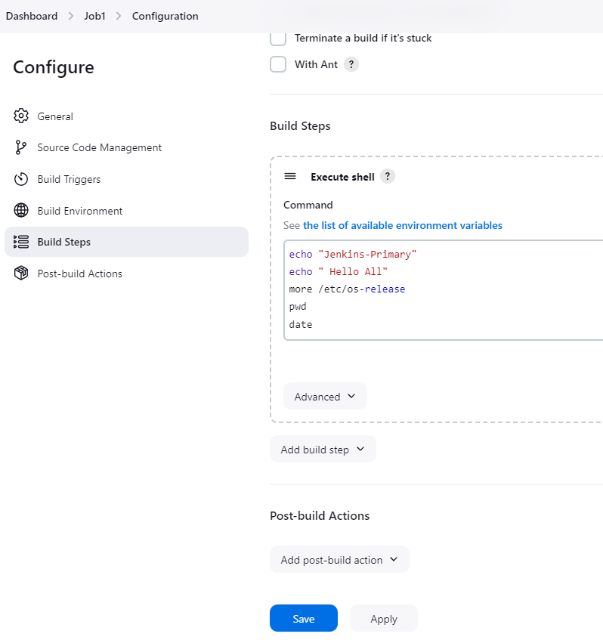

* Build Now and build is successful.

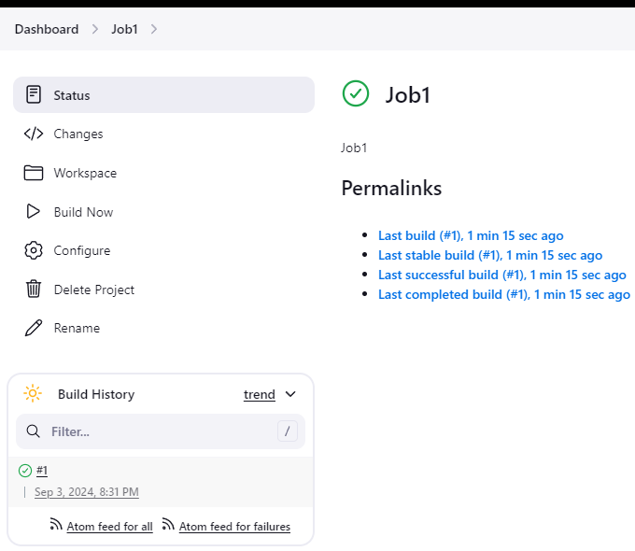

* console output shows the below output.

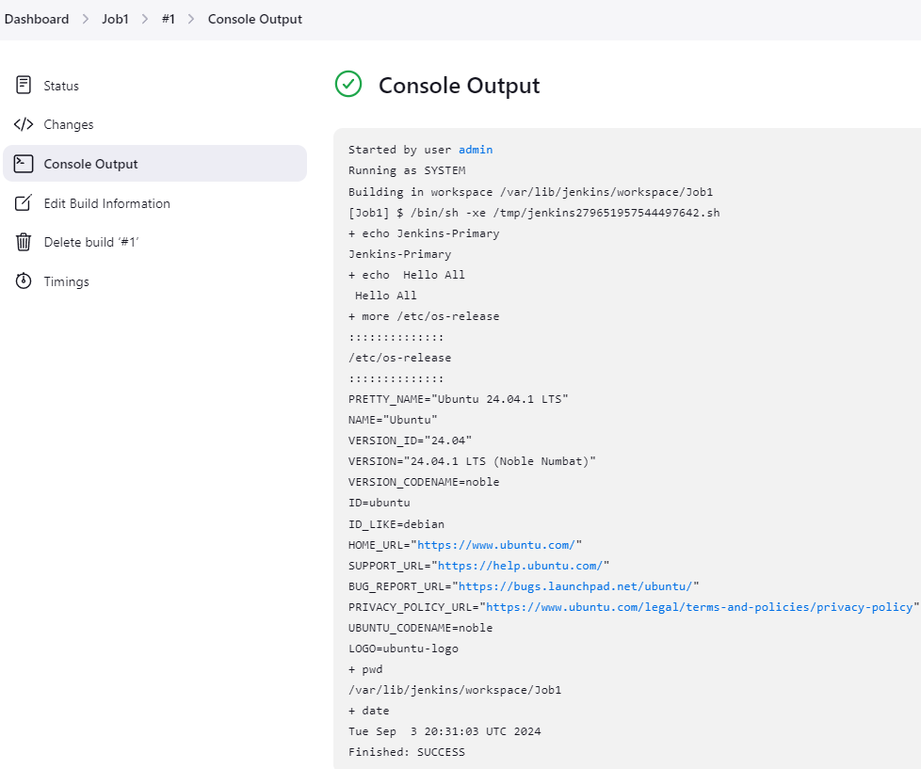

* Job 2 is pipeline project and below are the configurations.

General > Description > Job2

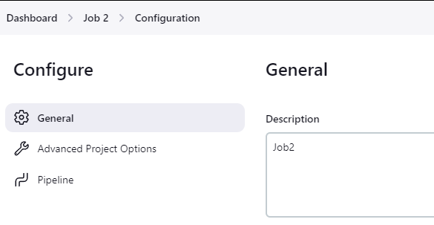

Under Pipline > Pipline script > Script

pipeline {

agent any

stages {

stage ("cleaningup workspace") {

steps {

cleanWs()

}

}

stage ("checkout scm code") {

steps {

checkout scmGit(branches: [[name: '*/main']], extensions: [], userRemoteConfigs: [[url: 'https://github.com/sourabh913/Devops_Notes_Assignments.git']])

}

}

}

}

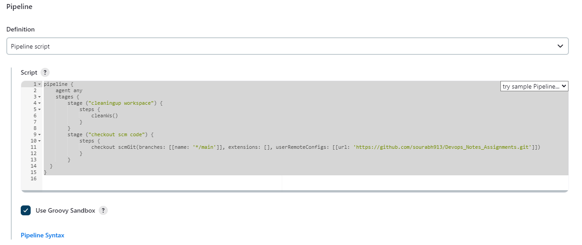

* Build Now and build is successful.

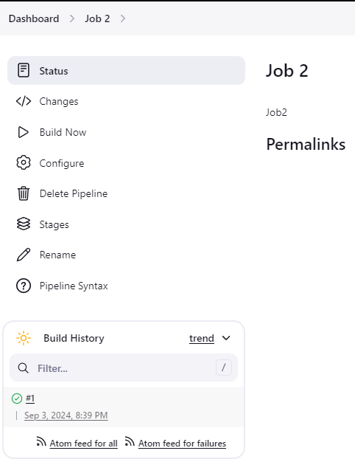

* console output shows the below output.

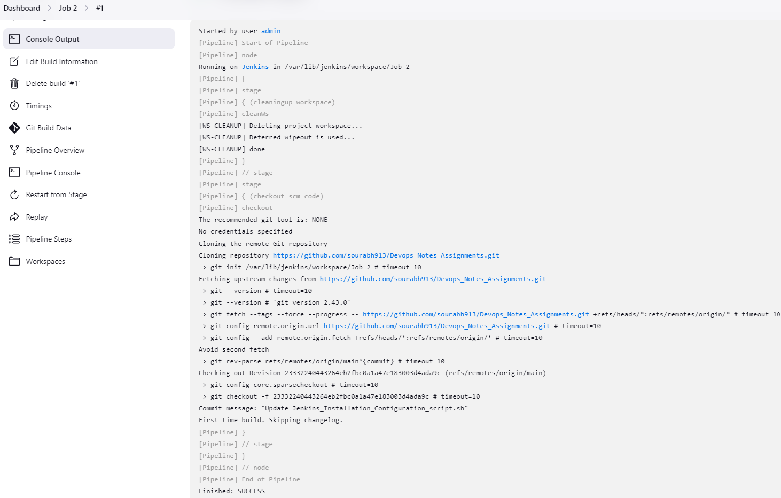

* For Backup perspective, we will install any available plugin which is not installed by default with recommended plugins. In our case we will install SonarQube Scanner plugin.

We will go to Manage Jenkins > Plugins

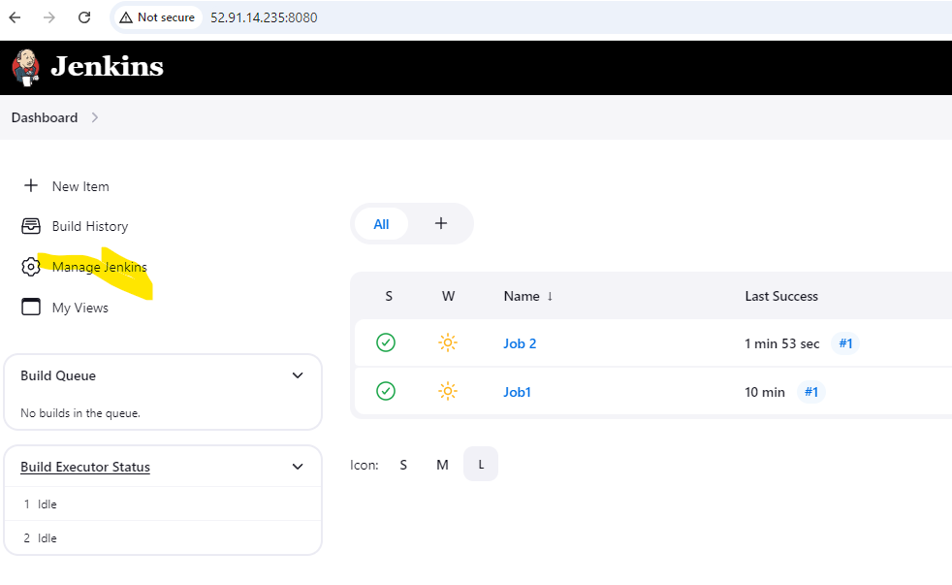

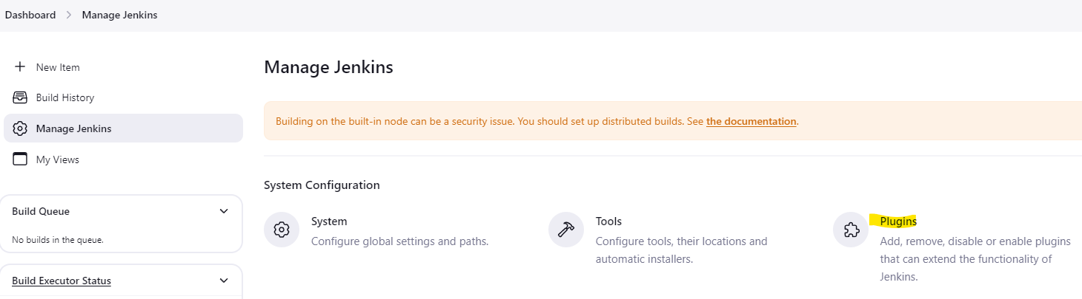

Under Available plugins > Select SonarQubeScanner > Install

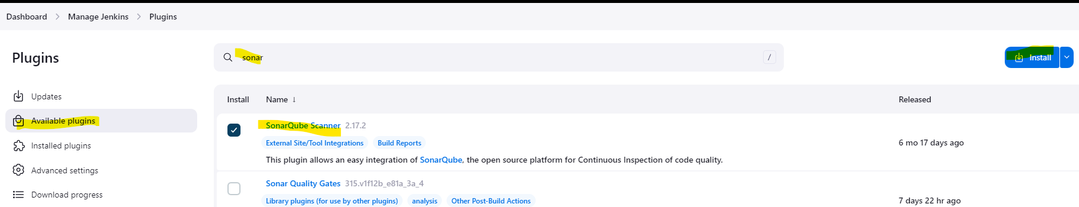

* Plugin installed successfully.

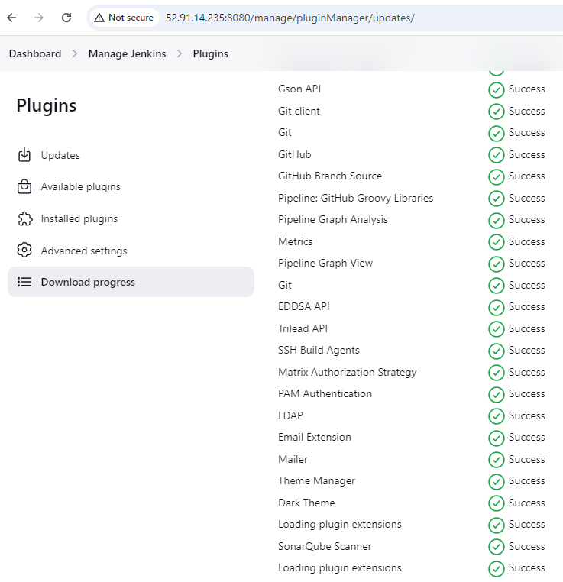

* **Now we will create S3 Bucket where we need to upload our backup**
* On the AWS Console, go to console and search S3 and click on it.

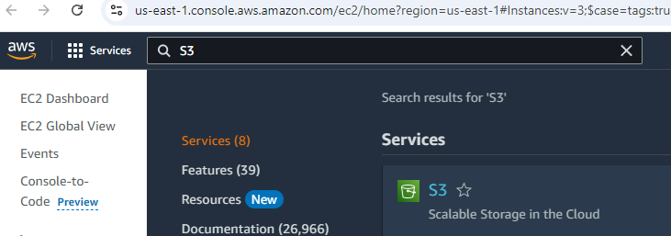

* Now Click Create bucket

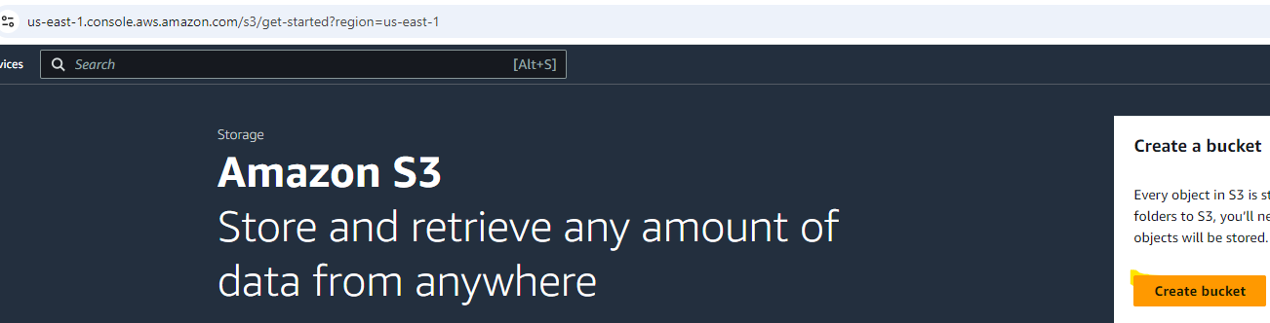

* Now under general configuration, keep everything as default and just give a unique name to S3 bucket and click create bucket. In our case, bucket name is jenkinss3backup

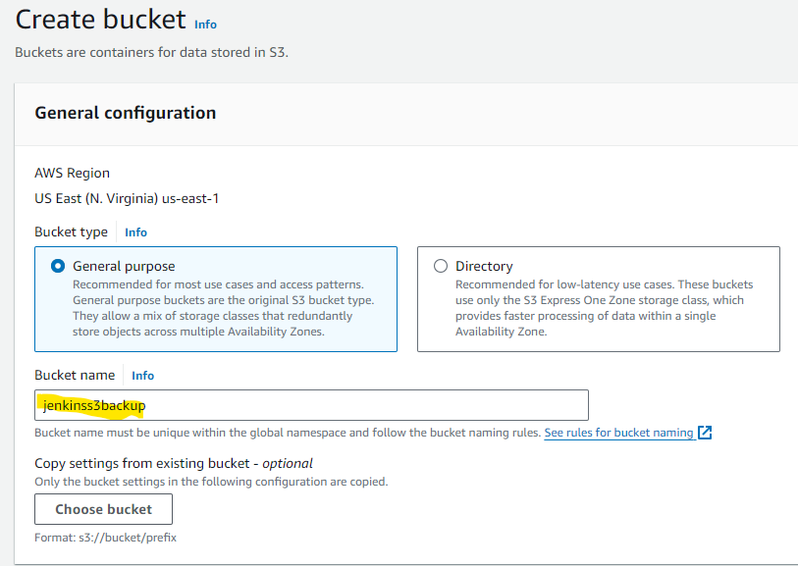

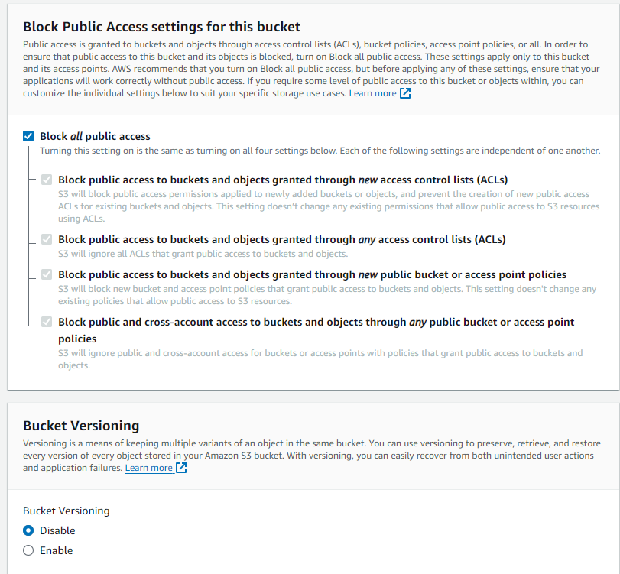

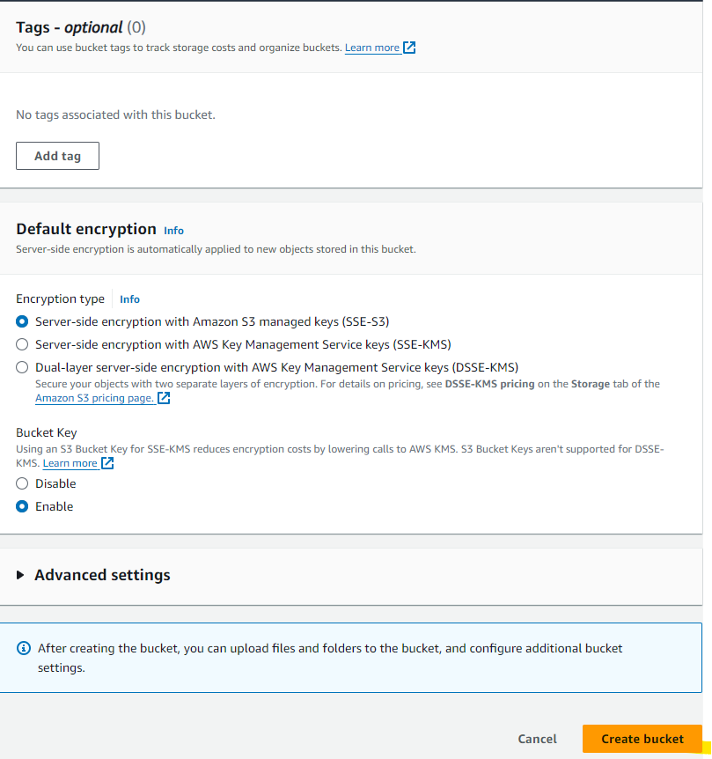

* Bucket is created successfully.

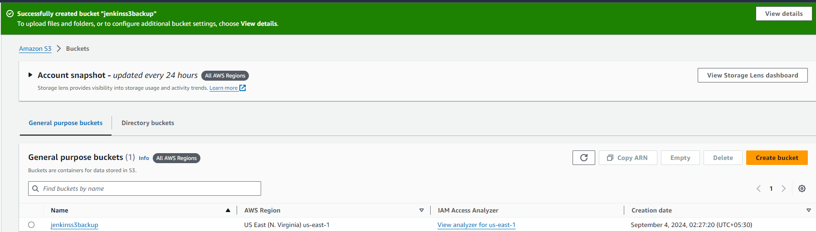

* Bucket is blank right now.

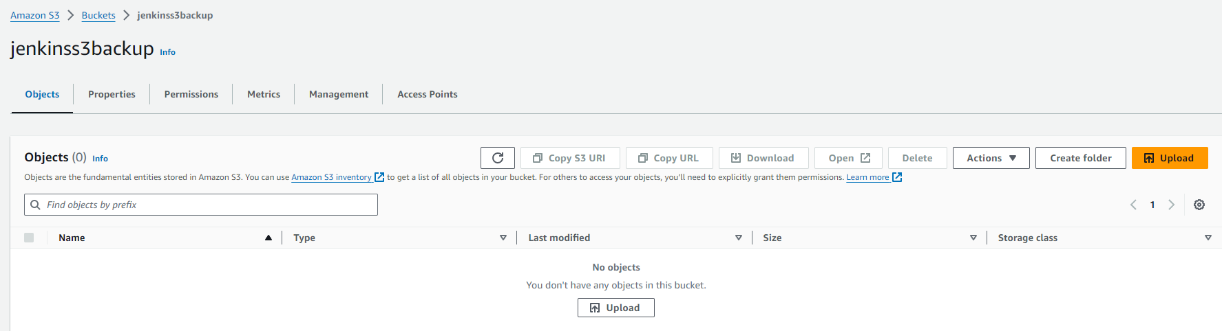

* **Now we will create the IAM Role for S3 full access**
* On the AWS Console, go to console and search IAM and click on it.

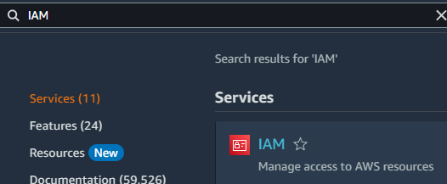

* Click on Roles under Access Management.

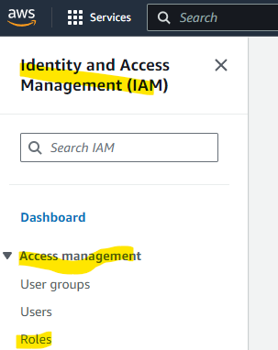

* Now Click Create Role.

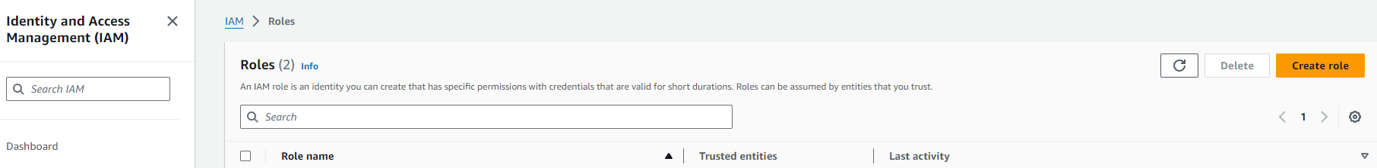

* Under Select Trusted Entity > Aws Service

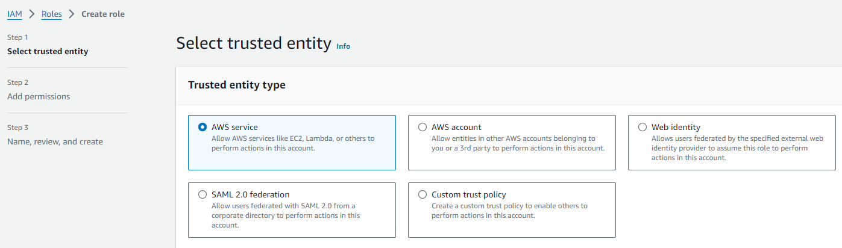

* Under Use Case > Drop down to EC2 and click Next

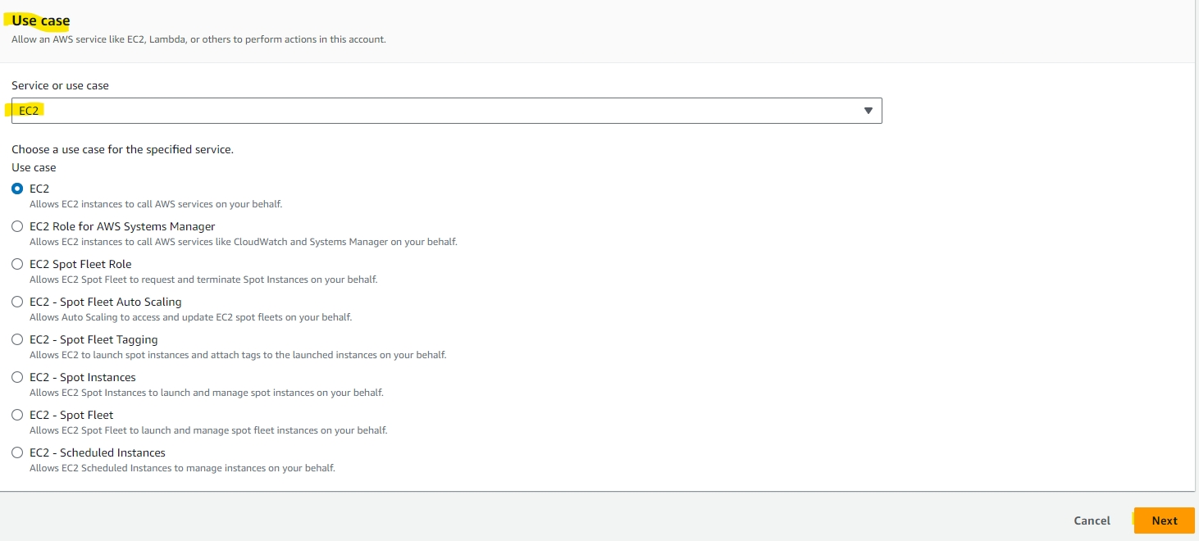

* Add Permissions > Search for S3 > AmazonS3FullAccess and click Next

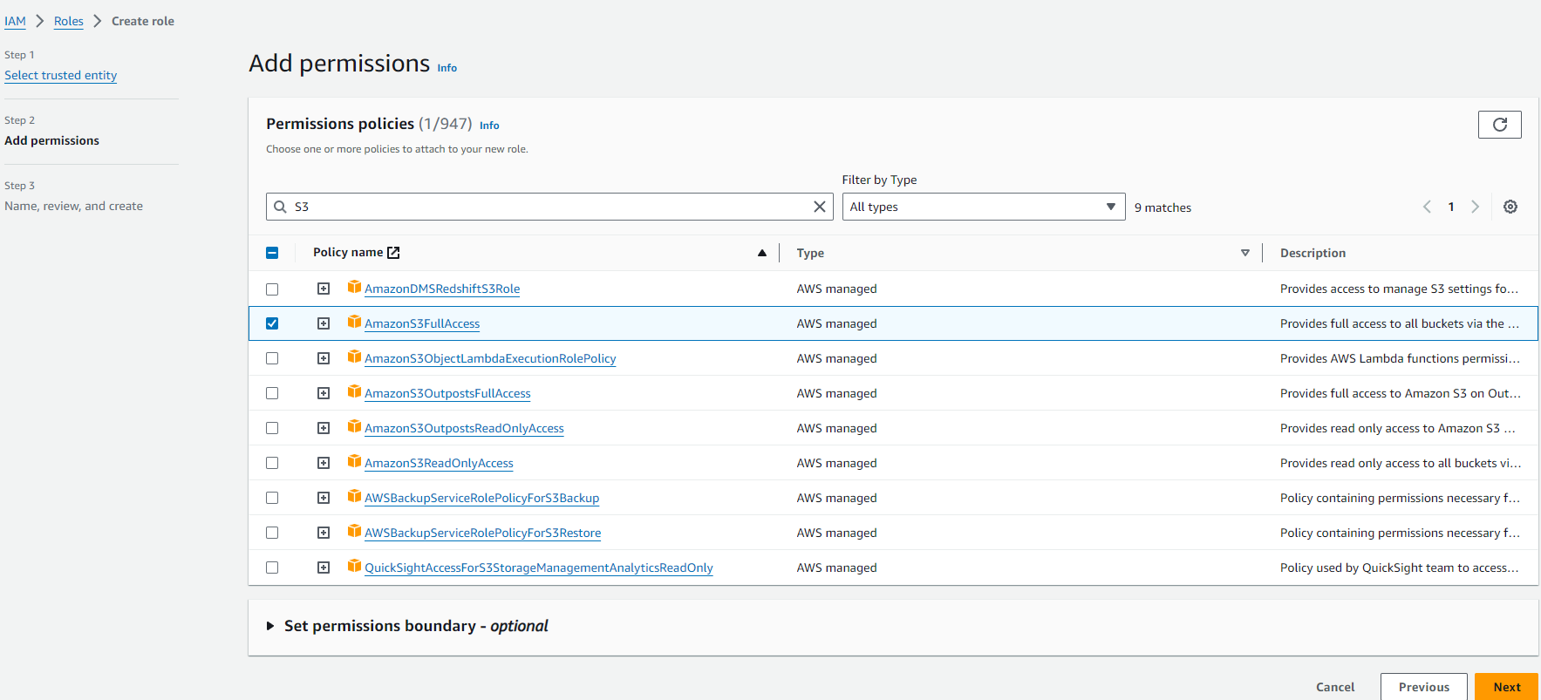

* Give the Role Name. In our case, It will be jenkinss3 and click create role.

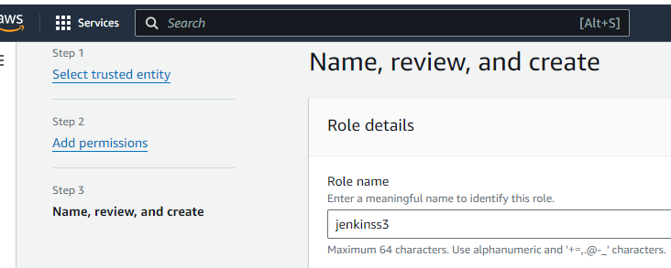

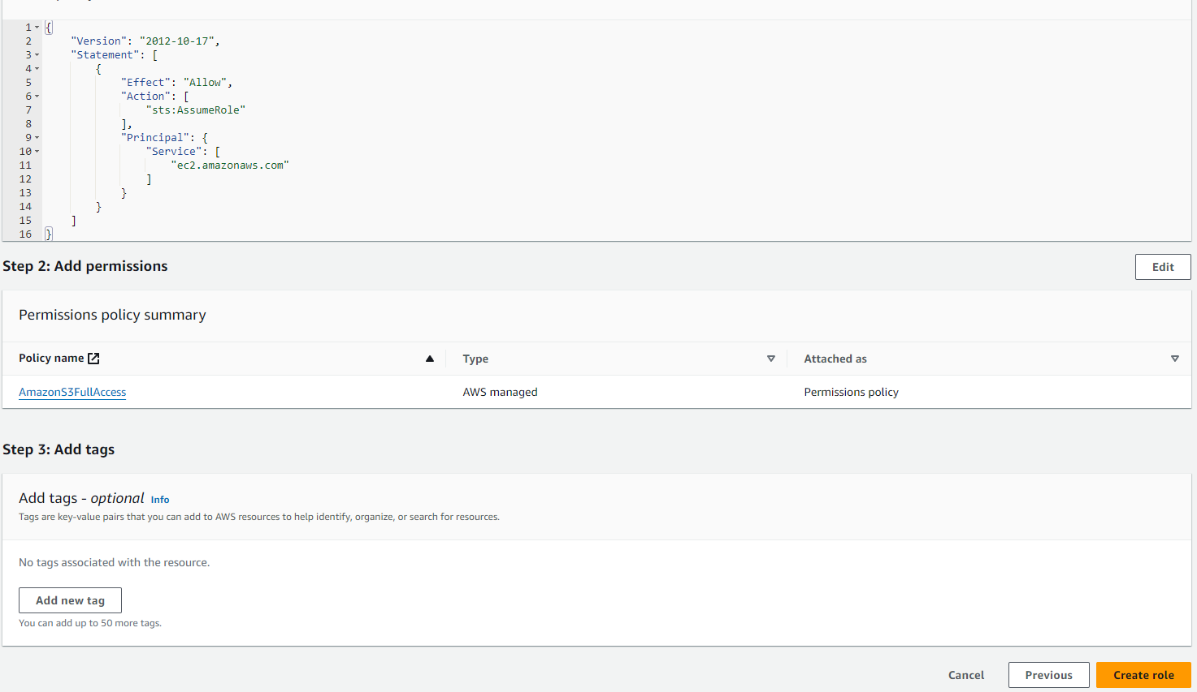

* Role is created.

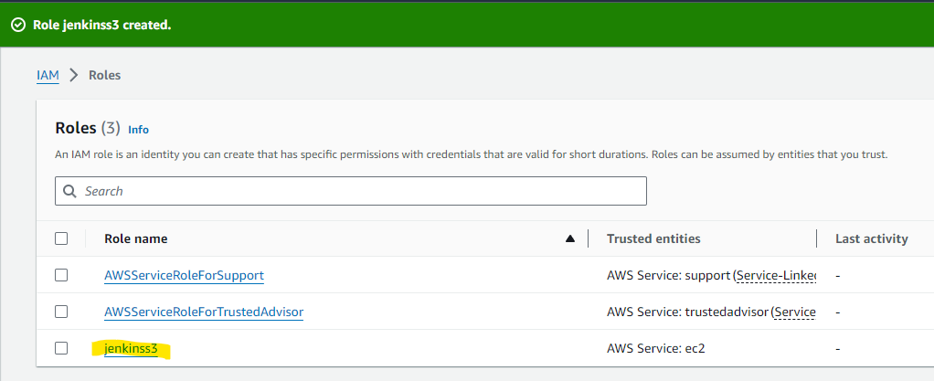

* **Now we will take the backup of first jenkins instance.**
* First of all, we need to stop the jenkins service by using the below command

systemctl stop jenkins



* Now, the most important folder which has all the configs, secrets, jobs and builds is the home path of jenkins /var/lib/jenkins

cd /var/lib/jenkins

ls -ltr

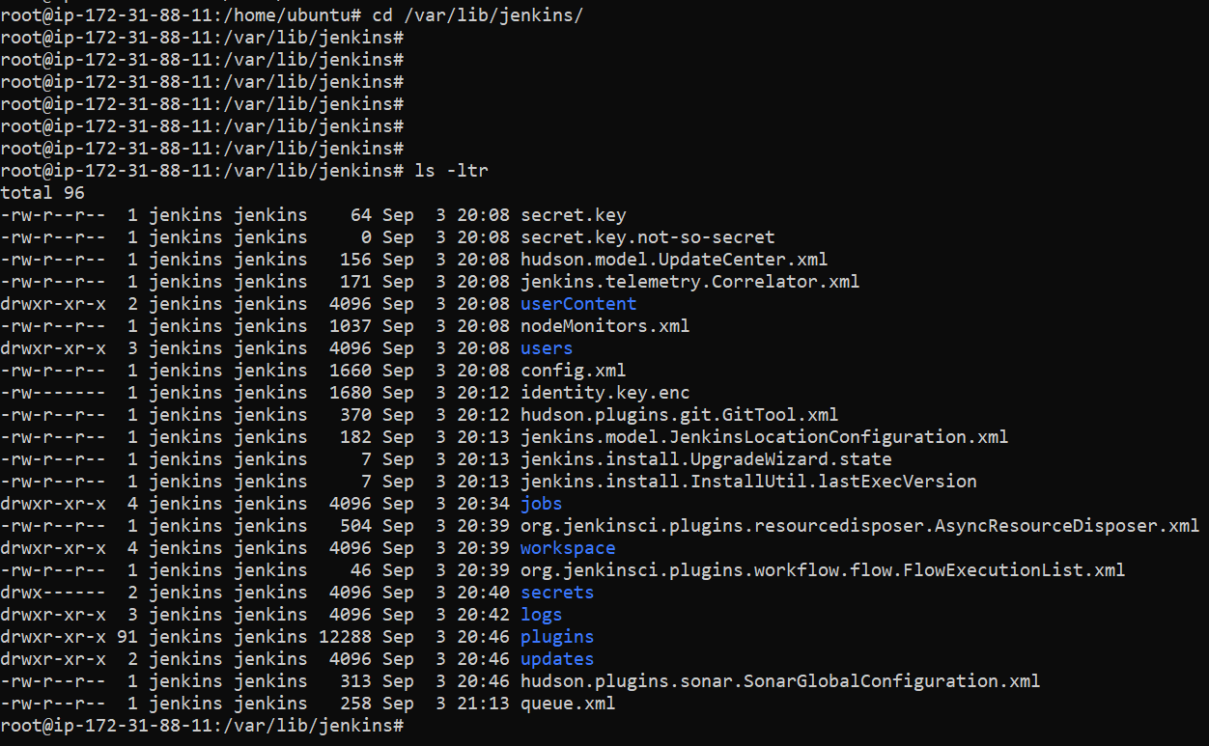

* Now we compress all the files & directories under /var/lib/jenkins by creating a tar file.

tar -zcvf <file-name> /var/lib/jenkins/

In our case, it’s as below

tar -zcvf jenkins-backup.tar.gz /var/lib/jenkins/

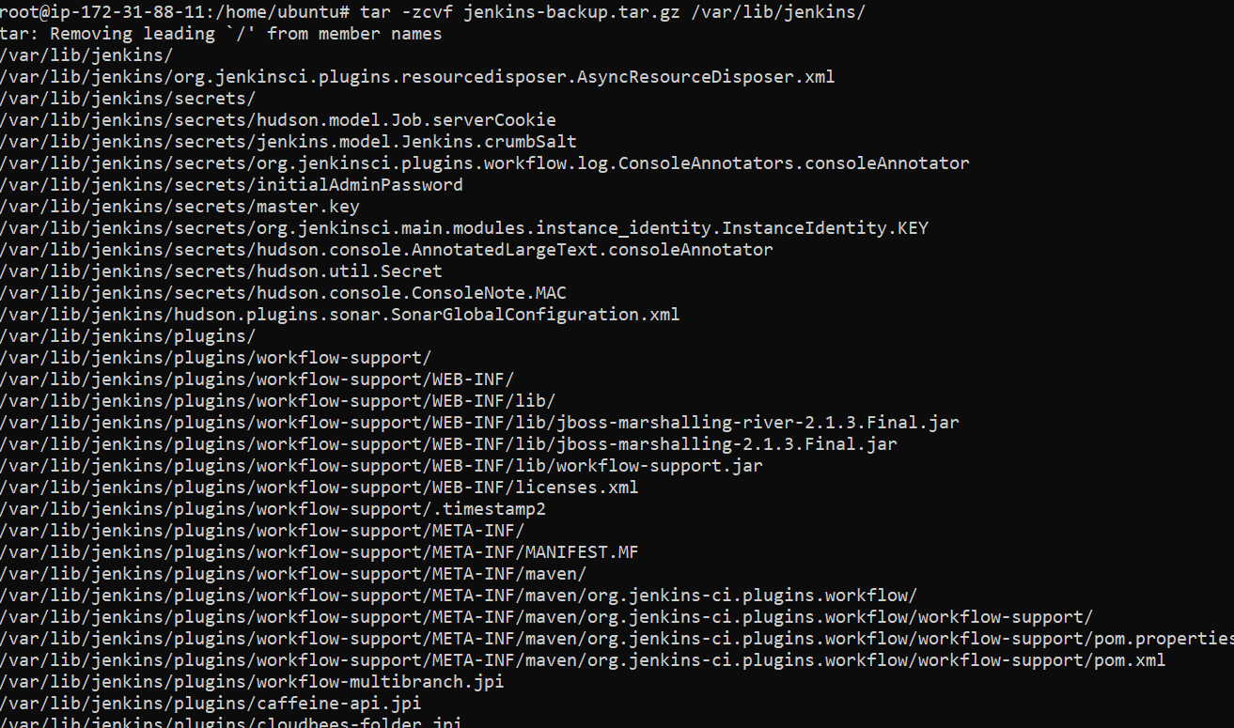

* All the files & directories under /var/lib/jenkins are compressed and tar file is created jenkins-backup.tar.gz

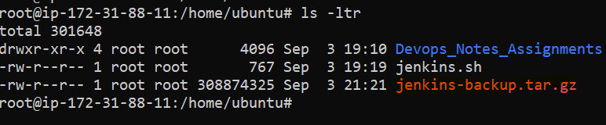

* **Now we will install AWS CLI**
* Get the zip file of aws cli using the below command.

**curl "https://awscli.amazonaws.com/awscli-exe-linux-x86_64.zip" -o "awscliv2.zip"**



* Now we will unzip the file, but before that we need to install **unzip** using the below command.

apt install unzip -y

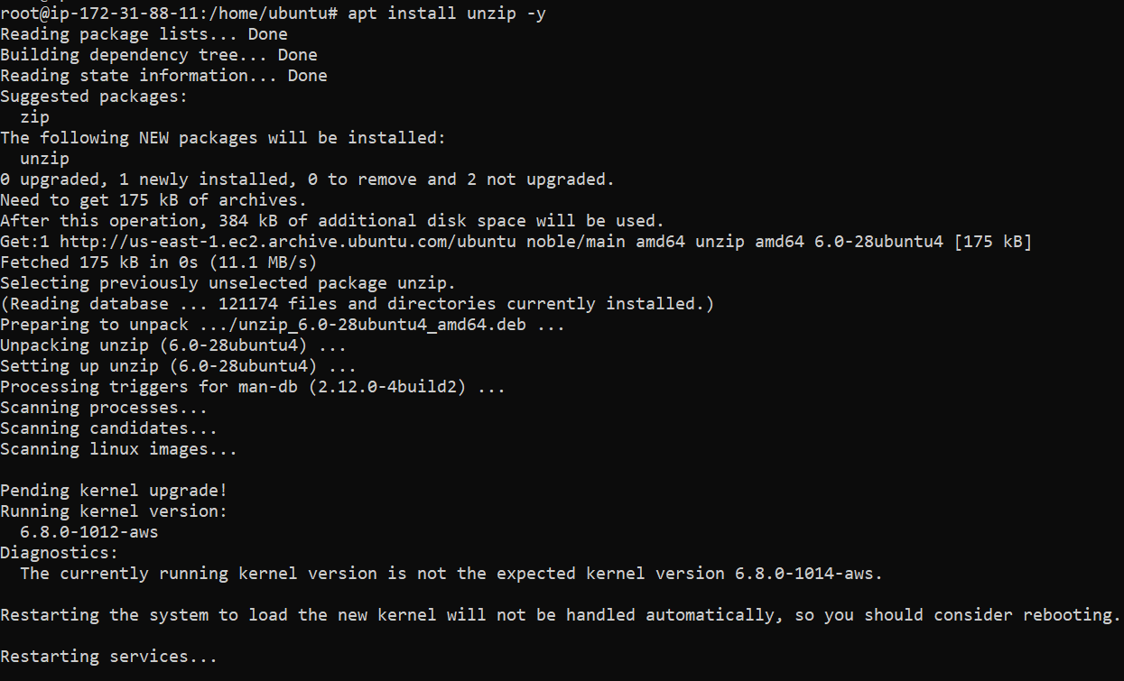

* Now we will unzip the file **awscliv2.zip** using the below command

unzip awscliv2.zip

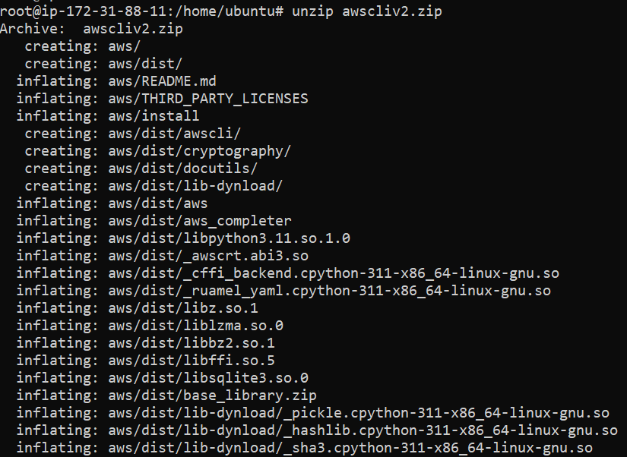

* Once the unzip of the file is done, we need to run the below command to install AWS CLI

./aws/install

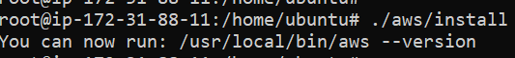

* We can verify that AWS CLI installed by typing below command.

aws

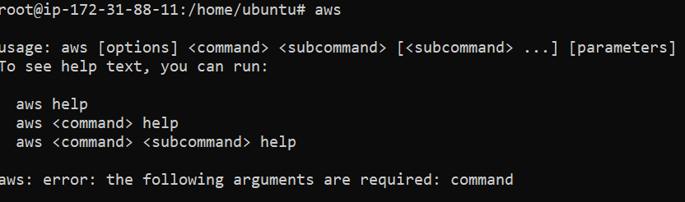

* **Now we will upload the jenkins-backup.tar.gz using the below command via AWS CLI.**

aws s3 cp <file-name> s3://<bucket-name>/<file-name>

In our case

aws s3 cp jenkins-backup.tar.gz s3://jenkinss3backup/jenkins-backup.tar.gz



* Upload failed due to credentials were not located.
* **Now we will attach the IAM Role to Jenkins Primary EC2 Instance**
* We will go to the below path and modify IAM Role

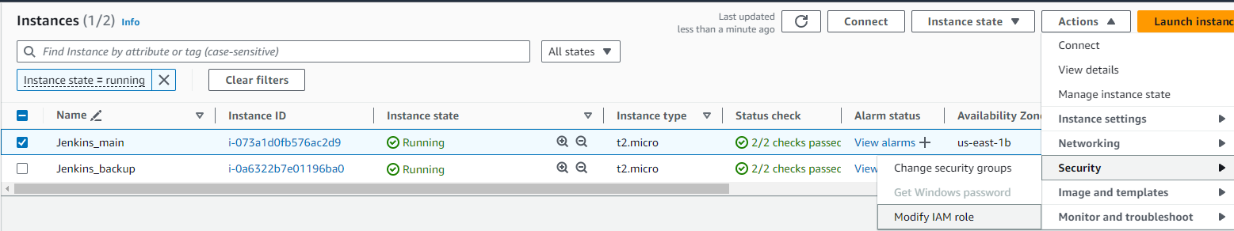

* We will choose the Role from dropdown and selectjenkinss3 and click update IAM role

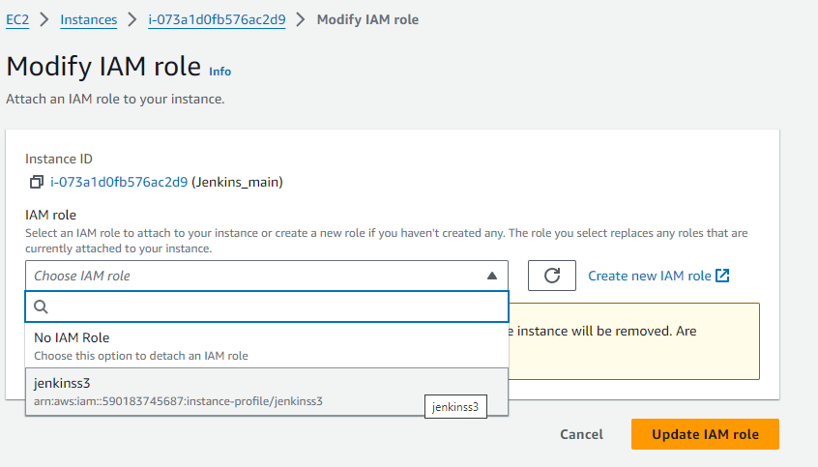

* **Now we will again upload the jenkins-backup.tar.gz using the below command via AWS CLI.**

aws s3 cp jenkins-backup.tar.gz s3://jenkinss3backup/jenkins-backup.tar.gz

Now file got uploaded successfully.



* Verified on S3 bucket also that upload was successful.

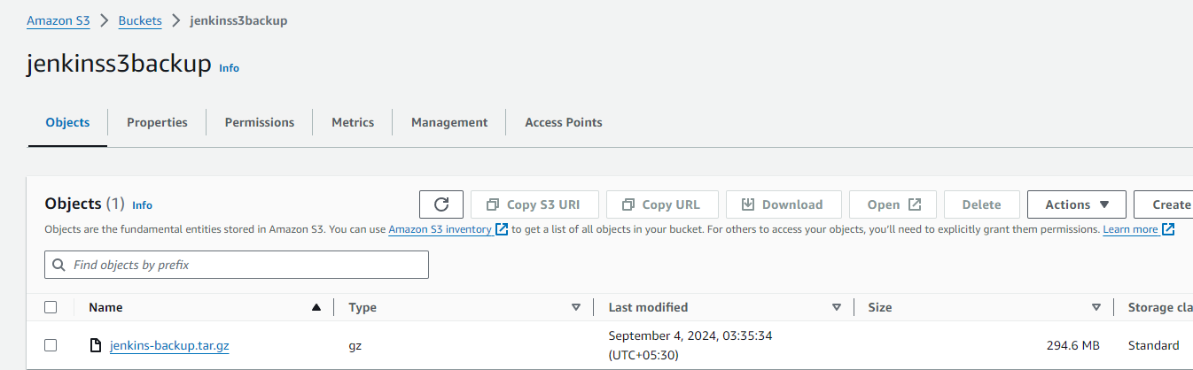

* **Now will terminate the first Jenkins instance.**

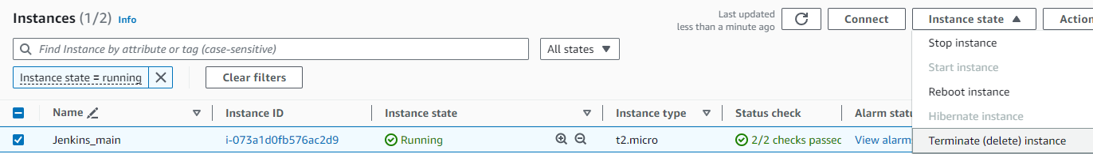

* **Now we will go on the Second Jenkins instance for restoring backup of first Jenkins instance.**
* We will have install AWS CLI again by following the same method.

Get the zip file of aws cli using the below command.

**curl "https://awscli.amazonaws.com/awscli-exe-linux-x86_64.zip" -o "awscliv2.zip"**



* Now we will unzip the file, but before that we need to install **unzip** using the below command.

apt install unzip -y



* Now we will unzip the file **awscliv2.zip** using the below command

unzip awscliv2.zip



* Once the unzip of the file is done, we need to run the below command to install AWS CLI

./aws/install



* We can verify that AWS CLI installed by typing below command.

aws



* we need to stop the jenkins service by using the below command

systemctl stop jenkins



* We need to remove the home path /var/lib/jenkins of current jenkins setup

rm –rf /var/lib/jenkins



* **Now we will download the jenkins-backup.tar.gz using the below command via AWS CLI.**

aws s3 cp s3://bucketname/filename filename

In our case

aws s3 cp s3://jenkinss3backup/jenkins-backup.tar.gz jenkins-backup.tar.gz



* Unable to locate credentials.
* **Now we will attach the IAM Role to Jenkins Secondary EC2 Instance**
* We will go to the below path and modify IAM Role

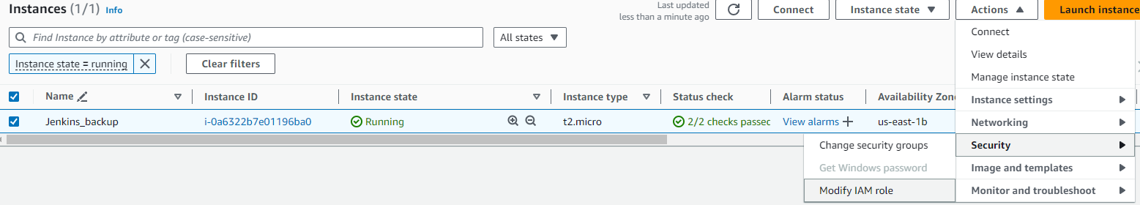

* We will choose the Role from dropdown and selectjenkinss3 and click update IAM role



* **Now we will again download the jenkins-backup.tar.gz using the below command via AWS CLI.**

aws s3 cp s3://jenkinss3backup/jenkins-backup.tar.gz jenkins-backup.tar.gz

File downloaded successfully on the Instance



* File is present on the location.

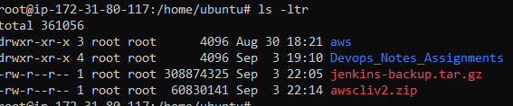

* Now will untar the file, so that it creates /etc/var/jenkins directory and copies all the backup of the primary instance.

tar -zxvf <file-name> -C /

In our case

tar -zxvf jenkins-backup.tar.gz -C /

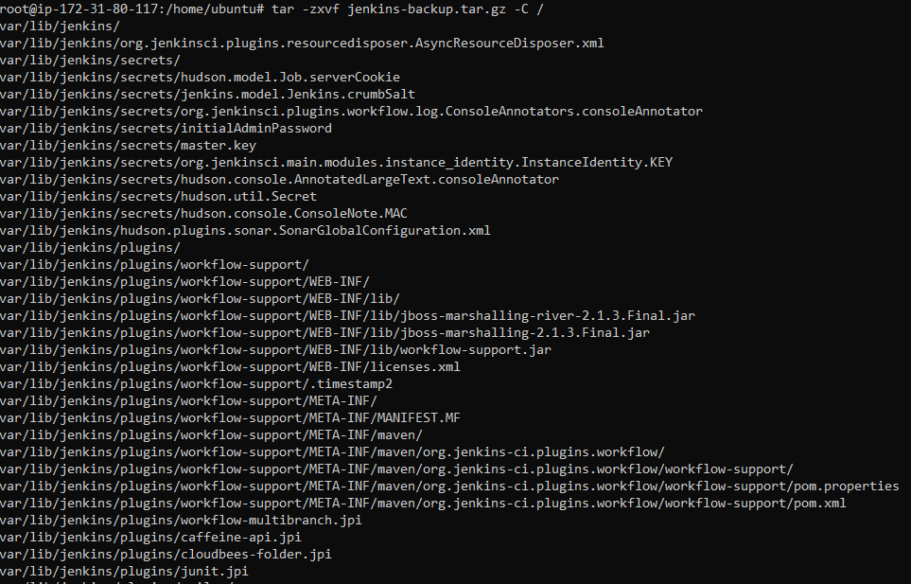

* Now we will start jenkins using the below command.

systemctl start jenkins



* Now we will verify, if we are able to login to the Jenkins using the credentials which we set for Jenkins Primary Instance.

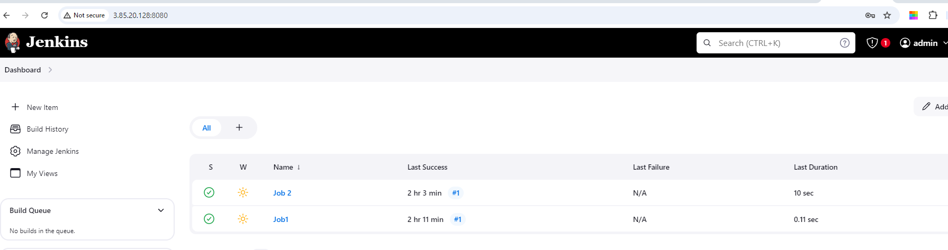

* We are able to login and we also see the jobs created in Jenkins Primary Instance.
* So, Jenkins Backup and Restore have been completed successfully.

1. **How to Secure Your Jenkins Server with HTTPS.**

* **Before starting, we need to have the following prerequisites**
* **A Jenkins Server Installed on EC2 Instance**
* **Open SSL Installed on the same EC2 Instance**
* A EC2 Instance is ready with Jenkins Server installed on it using the below shell script



* **Open SSL is installed using the below command.**

apt install openssl -y

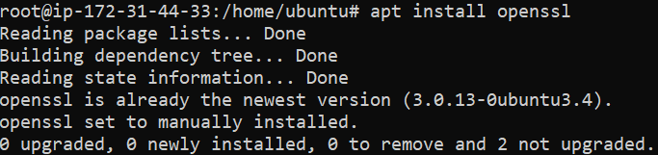

* **Generate SSL Certificate**
* The first step is to generate a self-signed SSL certificate using OpenSSL. Execute the following command: and follow the steps in below screenshot

openssl req -newkey rsa:2048 -nodes -keyout key.pem -x509 -days 365 -out certificate.pem

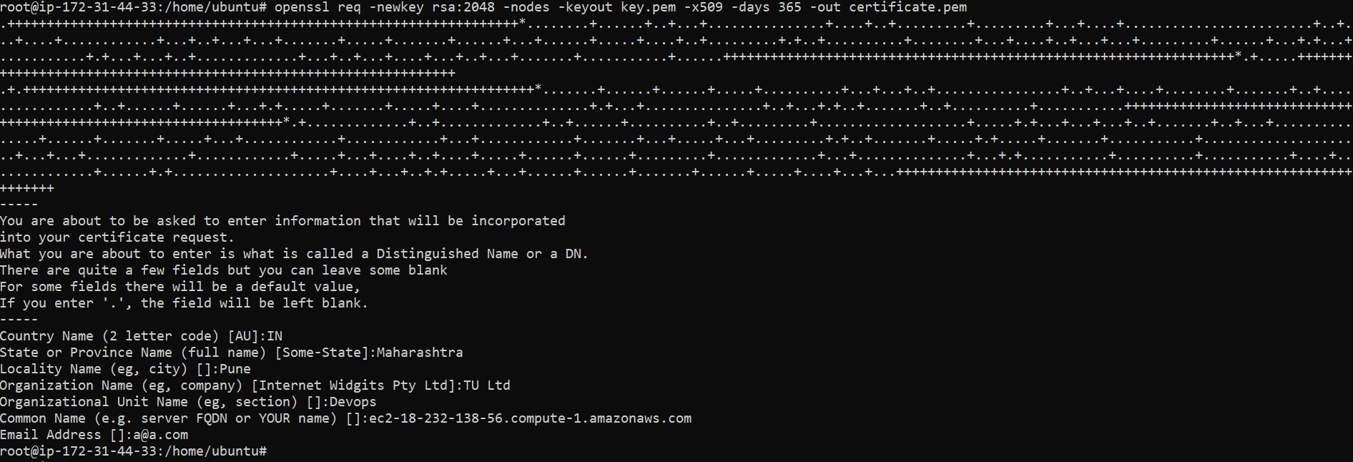

* **Create PKCS12 File**
* Now we willcreate a PKCS12 file from the generated key and certificate: Set an export password when prompted, verify it.

openssl pkcs12 -inkey key.pem -in certificate.pem -export -out certificate.p12



* **Import Certificate to Keystore**
* Now Import the PKCS12 file into a Java keystore (JKS) using the keytool command:

You'll need to enter the destination keystore password and the source keystore password.

keytool -importkeystore -srckeystore ./certificate.p12 -srcstoretype pkcs12 -destkeystore jenkinsbuilddevops.jks -deststoretype JKS

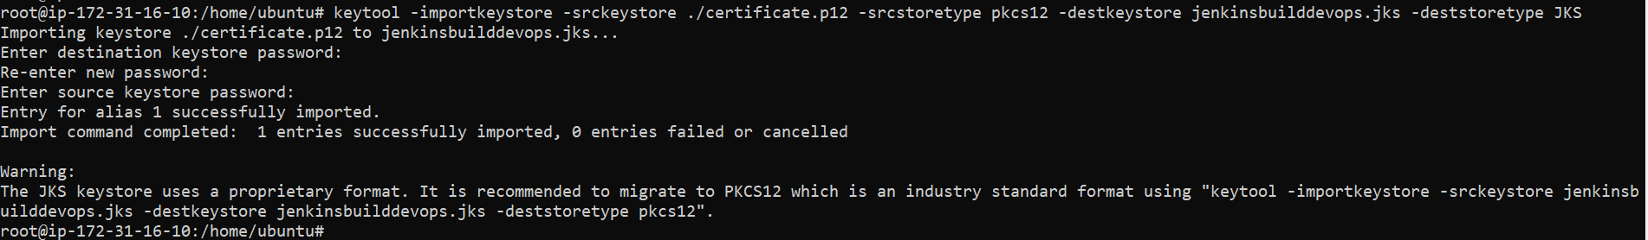

* **Move Keystore to Jenkins Directory**
* Now Move keystore to jenkins directory. Copy the generated keystore file to the Jenkins directory:

cp -pav jenkinsbuilddevops.jks /var/lib/jenkins/



* Set Jenkins HTTPS Configuration**:** Modify the Jenkins service configuration to enable HTTPS. Edit the Jenkins service file:

vi /usr/lib/systemd/system/jenkins.service



Change the below line

Environment="JENKINS_PORT=8080"

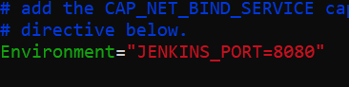

Environment="JENKINS_HTTPS_PORT=8090"

Environment="JENKINS_HTTPS_KEYSTORE=/var/lib/jenkins/jenkinsbuilddevops.jks"

Environment="JENKINS_HTTPS_KEYSTORE_PASSWORD=abc123"



* Reload the systemd daemon and restart the Jenkins service:

systemctl daemon-reload

systemctl restart jenkins

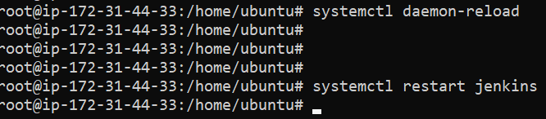

* Now we will verify the https connection on the new port for Jenkins i.e. port 8090

